The Vulva

General The vulva is a portal for a variety of functions (reproductive and excretory) and has a unique role in sexual feelings and function.

Because it is covered with both dry, squamous skin and moist mucous membrane, it is subject to diseases affecting both. Because of the close proximity of the rectum, intestinal bacteria (anaerobes and coliforms) are more or less constantly present to some degree. These may influence the type and course of infections in this area.
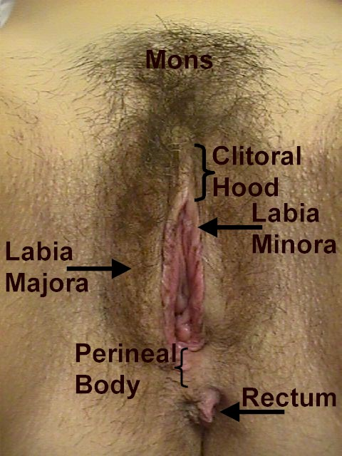

The vulva may develop conditions both benign and malignant, symptomless, annoying, or even disabling

Bartholin Cyst and Abscess The Bartholin glands are located on each side of the vaginal opening at the level of the posterior fourchette. Normally, they are neither visible nor palpable.

Bartholin cysts are painless swellings in the labia majora. They are not infected and can be safely watched. They may occur following trauma or infection, but many are essentially spontaneous. It is a relatively simple procedure to drain them, but in operational settings, there is little need to do that as they are generally without symptoms.

When infected (Bartholin abscess), the labia majora becomes excruciatingly painful. Some of these will drain spontaneously within 72 hours. This process may be hastened by warm moist dressings or sitz baths.
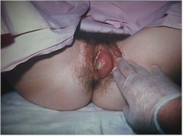
Incision and Drainage of the abscess gives immediate relief.
- Give local anesthetic of 1% Xylocaine over the incision site (thin area of skin medial to the cyst).
- Steady the cyst or abscess with one hand while a scalpel is directed into the center of the abscess.
- Purulent drainage should be cultured for gonorrhea.
- Antibiotic therapy is optional but wise, particularly if the patient is febrile, the abscess large, or the skin is red or tender.

Recurrent Bartholin abscesses are common and these may need surgical removal, marsupialization, or insertion of a Word Catheter. These are best handled by a gynecologic surgeon. In an isolated military setting, a simple incision and drainage procedure will always be temporarily effective and is a reasonable choice.

Chancroid This sexually-transmitted illness begins as a tender, reddened papule filled with pus. It then breaks down, ulcerates and reveals a grayish, necrotic base with jagged, irregular margins.

There is no significant induration around the base, unlike primary syphilis. In untreated cases, the lesions may spread and substantial tissue damage may result. Tender, enlarged inguinal lymph nodes are found in 50% of patients.
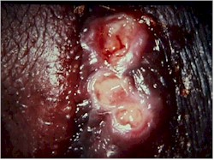

Hemophilus ducreyi, the causative organism, is difficult to culture, so the diagnosis is made on the basis of history, physical exam and exclusion of other ulcerative diseases of the vulva. A gram-stain from the base of a clean ulcer or aspirate from a bubo may reveal a gram-negative coccobacillus clustered in groups around polymorphonucleocytes ("school of fish " appearance).

Good choices for treatment include any of the following:
- Azithromycin 1 g orally in a single dose,
- Ceftriaxone 250 mg intramuscularly (IM) in a single dose,
- Ciprofloxacin 500 mg orally twice a day for 3 days,
- Erythromycin base 500 mg orally four times a day for 7 days.

Condyloma Lata These skin lesions are associated with secondary syphilis and resemble condyloma acuminata (venereal warts), except their surface is smooth. They are raised, painless, flat lesions. Examination of the surface scrapings under darkfield microscope will show the typical spirochetes. Serologic test for syphilis (VDRL, RPR) will be positive.
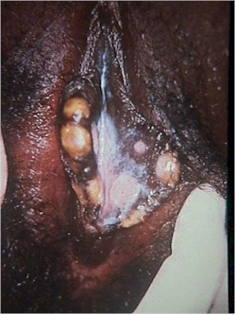
Optimal treatment is:
- Benzathine penicillin G 2.4 million units IM in a single dose

For those allergic to penicillin, you may substitute:
- Doxycycline 100 mg orally twice a day for 2 weeks, or
- Tetracycline 500 mg orally four times a day for 2 weeks.

If the patient is pregnant, tetracyclines should not be used. Should the pregnant patient also be allergic to penicillin, desensitization is recommended by many, but operational circumstances may not allow for that. In such cases erythromycin or Azithromycin can be effective, although the optimal dosage is unknown. The main concern here is that if insufficient antibiotic gets across the placenta and to the fetus, fetal syphilis will be insufficiently treated.

Contact Dermatitis A variety of chemical substances can cause local irritation of the skin. The vulva, because of its' mucous membrane and confined space, is more sensitive to these chemicals than many other areas of the body.

Perfumes, soaps, detergents, feminine hygiene products, contraceptives (latex, creams, jellies), and medications have all been the cause of vulvar contact dermatitis.

Contact dermatitis presents as a raised, itchy, red lesion in the area of contact with the irritating substance. The areas where skin touches skin are particularly sensitive since the irritating substance is held in place by the opposing skin surfaces. This creates a "butterfly" shaped rash in many patients.

Treatment consists of identifying and eliminating the irritating substance. In severe cases, Burrow's Solution soaks will provide immediate relief and topical steroid cream will give intermediate term relief.

Epithelial Polyp These painless, soft, fleshy, innocent growths arise from the labia majora. They are dry, non-tender and usually stable over many years.

They can be safely ignored. If the patient finds one annoying, it is easily removed. However, in many operational settings, the risk of subsequent infection might outweigh the convenience of removing the polyp.

Granuloma Inguinale This is a chronic, progressive, ulcerative, sexually-transmitted disease, involving the vulva, vagina or cervix.

The initial lesion is a papule, which undergoes central necrosis to form a clean, granulomatous, sharply-defined ulcer. This process continues, with development of multiple, confluent ulcers, which may be painful or painless. The ulcers have a beefy red base, which bleeds easily. Pseudobuboes in the groin can be felt.

The diagnosis is confirmed with biopsy of the ulcer, showing Donovan bodies on H&E stain or Giemsa stain.

This condition is rare in the United States, but somewhat more common in the tropical areas of southern Africa, India and New Guinea.

Treatment is
- Trimethoprim-sulfamethoxazole one double-strength tablet orally twice a day for a minimum of 3 weeks, or
- Doxycycline 100 mg orally twice a day for a minimum of 3 weeks, or
- Ciprofloxacin 750 mg orally twice a day for a minimum of 3 weeks, or
- Erythromycin base 500 mg orally four times a day for a minimum of 3 weeks.

Therapy should be continued until all lesions have healed completely.

Prognosis is excellent when treated in its early stages. Delayed treatment is associated with extensive scarring of the vulva, rectum and groin.

Herpes Vulvitis A tingling or itching sensation precedes the development of painful blisters on both sides of the vulva in acute herpes infection. The blisters then break open, releasing clear fluid, and form shallow ulcers, filled with grayish material. The ulcers then crust over and when the crusts fall off, the underlying skin looks normal. The process takes 7-10 days.
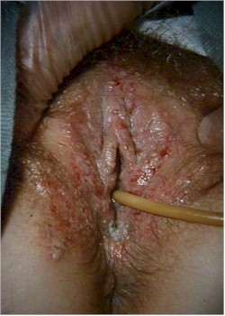

During the ulcerative stage, the pain may be so intense as to require narcotic analgesia. Urinating during this time can be extremely painful due to the hot, salty urine coming in contact with the open sores on the vulva. The pain may be so intense as to require such measures as urinating into a sitz bath or even placement of an indwelling urinary catheter (Foley).

The diagnosis is made by the typical appearance and may be confirmed with a herpes culture.
Although this lesion resolves spontaneously, re-occurrences are common.

Preferred treatment (CDC) for an initial outbreak is:
- Acyclovir 400 mg orally three times a day for 7-10 days, OR
- Acyclovir 200 mg orally five times a day for 7-10 days, OR
- Famciclovir 250 mg orally three times a day for 7-10 days, OR
- Valacyclovir 1 g orally twice a day for 7-10 days.

Preferred treatment (CDC) for a recurrence is:
- Acyclovir 400 mg orally three times a day for 5 days, OR
- Acyclovir 200 mg orally five times a day for 5 days, OR
- Acyclovir 800 mg orally twice a day for 5 days, OR
- Famciclovir 125 mg orally twice a day for 5 days, OR
- Valacyclovir 500 mg orally twice a day for 5 days.

Some individuals have frequent recurrences, as often as every several weeks. For these women, "suppressive therapy" can be very helpful. Suppressive therapy involves taking relatively low doses of anti-viral medication daily, in order to keep the virus from causing such frequent attacks. Suggested regimens (CDC) for suppressive therapy include:
- Acyclovir 400 mg orally twice a day, OR
- Famciclovir 250 mg orally twice a day, OR
- Valacyclovir 250 mg orally twice a day, OR
- Valacyclovir 500 mg orally once a day, OR
- Valacyclovir 1,000 mg orally once a day.

Another component of a herpes outbreak can be a bacterial superinfection. During the ulcerative stage, skin bacteria (strep, staph, and coliforms) can attack the exposed ulcers, causing a bacterial infection of the ulcer. This is particularly true of large or multiple, confluent ulcers. These women may benefit (faster recovery and less pain) by the use of antibiotics such as amoxicillin, any cephalosporin or erythromycin, even though those drugs will have no effect on the course of the viral component of the herpes.

Hypertrophic Vulvar Dystrophy Hypertrophic vulvar dystrophy means the skin of the vulva has grown thicker than it should be.

Associated with this thickening are the symptoms of intense itching and burning. These cases present clinically as patients with vulvar itching, initially believed to be yeast, which have failed to respond to standard anti-fungal therapy.

On close inspection, the skin has a patchy white discoloration. A vulvar biopsy confirms the diagnosis.
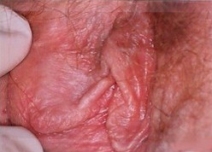

Treatment is topical steroids, used to thin the skin and relieve the symptoms.

Vulvar biopsy is very important in these cases since differentiating visually between Hypertrophic vulvar dystrophy, lichen sclerosis, and VIN (vulvar intraepithelial neoplasia) is difficult and the treatments are very different. Further, mixed dystrophies (hypertrophic in some areas, and lichen sclerosis in other areas.) are common.

Inclusion Cyst Inclusion cysts are common, innocent, symptomless swellings at the introitus of the vulva.

They are often a result of healing of an episiotomy or vulvar laceration following vaginal delivery but can occur spontaneously. An epithelial gland just beneath the skin, which normally would drain its' secretions to the surface of the skin, becomes trapped beneath the skin. Secretions accumulate, forming a small cyst.
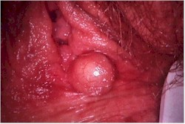

These cysts have a very thin skin covering and often, visible blood vessels can be seen coursing across the cyst.

No treatment is necessary, but for a woman who finds the cyst annoying, it can be opened and drained. While it could re-form, it usually won't. Draining of this type of cyst might not be considered a good idea in some operational settings because the risk of infection at the incision site.

Itching At least 90% of all women who complain of vaginal or vulvar itching will have yeast as at least a portion of the problem.

Because of this, simply treating these patients with a reliable anti-fungal agent (Monistat, Mycelex, Lotrimin, Diflucan, etc.) without a detailed history, physical and laboratory evaluation, is often expedient and successful. In many operational settings, this therapeutic approach is particularly useful as it requires no laboratory or physical examination.

For those in whom itching persists, a careful history and physical exam will usually be needed to determine the cause of the itching.

When available, some tests which may be used in determining the cause of the itching, including vaginal cultures (for strep), wet mount (for yeast, Trichomonas and bacterial vaginosis), vulvoscopy (magnified inspection of the vulva) and directed skin biopsies.

Less common causes of vulvar itching include hypertrophic vulvar dystrophy, lichen sclerosis, HPV, Paget's disease, VIN, contact dermatitis, psoriasis of the vulva and lice.

Labial Abscess A labial abscess presents as a firm, very tender, reddened, unilateral mass.
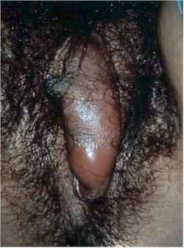
The mass arises from the upper portion of the labia, in contrast to Bartholin cyst abscesses, which arise from the lower (inferior) portion of the labia.

Causes include infectious complications of trauma and infected skin glands.

Many of these will drain spontaneously, but a simple incision and drainage procedure will provide dramatic, immediate relief of symptoms. Make the incision through the thinnest portion of the abscess wall, but this will generally be in the inferior, medial aspect of the mass.

While antibiotics may be optional in a civilian setting, they are usually very desirable in an operational setting. Good choices include any antibiotic with reasonable effectiveness against common skin organisms (amoxicillin, cephalosporins, erythromycin, Azithromycin, clindamycin).

Complete resolution of symptoms and restoration of the normal anatomy is the expected outcome.

Lichen Sclerosis Lichen sclerosis is one form of vulvar dystrophy. With lichen sclerosis, the skin of the vulva is too thin.
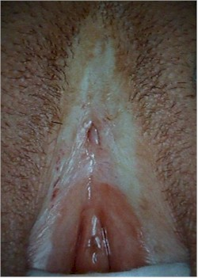
Clinically, women with lichen sclerosis complain of chronic vulvar itching and irritation. Tissues may be fragile, tear easily and result in superficial bleeding. Using only casual observation, the vulva may appear normal, but closer inspection will reveal a whitish discoloration and loss of anatomic differentiation of the vulvar structures.

It may be difficult, without a vulvar biopsy, to distinguish lichen sclerosis from the other forms of vulvar dystrophy (hypertrophic vulvar dystrophy and mixed dystrophy). For this reason, women suspected of having lichen sclerosis usually undergo vulvar biopsy to confirm the diagnosis.

Lichen sclerosis can occur in any age group, is not related to lack of estrogen, and its' cause is not known.

As a general rule, topical steroids give only very limited relief and if used for any length of time (more than 2 weeks) can make the condition worse because they tend to thin the skin even more. The important exception to this rule is the topical synthetic fluorinated corticosteroid, Clobetasol, which has been very effective in eliminating symptoms and restoring the normal anatomy of the vulva.
- 0.05% clobetasol propionate cream is applied to the vulva twice daily for one month, than at bedtime for one month and then twice a week for three months. It is then used as needed one or two times per week. Using this approach, 95% of patients will notice significant improvement and 75% will report complete remission of symptoms.

Traditional therapy consists of
- 2% testosterone propionate in petroleum jelly, applied 3 times a day for 3 to 6 months or until the symptoms are relieved. Then the applications are gradually reduced to a level of one or two applications per week.

LGV Lymphogranuloma venereum is an uncommon sexually-transmitted disease caused by a variant of Chlamydia trachomatis.

Following initial exposure, there is mild, blister-like formation, which is frequently unnoticed. Within the following month, there is ulceration of the vaginal, rectal or inguinal areas. At this stage, the disease is very painful, particularly with walking, sitting and with bowel movements. The stool may be blood-streaked.

Hard tender masses (buboes) arise in the inguinal area at this stage and are characteristic of the disease.

As the disease progresses untreated, extensive scarring in the rectal area may require surgery to enable normal bowel movements. Scarring in the vaginal area can lead to painful intercourse or make intercourse basically impossible.

Confirmation of the disease is optimally achieved with a positive Chlamydia trachomatis serotype culture from a bubo. Often, less specific tests, such as serum complement fixation test with acute and convalescent samples are used. In many operational settings, none of these tests are available and the diagnosis is made by history of exposure, visual appearance of the lesions and known prevalence in the population.

Optimal treatment is:
- Doxycycline 100 mg orally twice a day for 21 days, or
- Erythromycin base 500 mg orally four times a day for 21 days.

Because Azithromycin is effective against other presentations of Chlamydia trachomatis, it is likely, but unproven that use of multiple doses over several weeks would be effective against LGV.

Melanosis Melanosis is the benign pigmentation of the mucosal surface of the vulva.

The areas are multiple, flat, and stable. Biopsy, if performed, will show clusters of melanocytes with a benign appearance.

The cause is unknown but genetics presumably plays a role. Left alone, they will remain stable for long periods of time, but may fade following childbirth.

As they do not pose a threat and are not a cosmetic issue, no treatment is necessary.

Suspicious areas or areas that are rapidly changing should be biopsied.

Molluscum Contagiosum This sexually-transmitted pox-virus causes small, benign skin tumors to grow on the vulva, which are usually symptomless.

The tumors appear as dome-shaped lumps, 1-2 mm in diameter with tiny dimples in their center, and contain a white, cheese-like material.
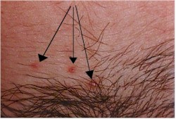

Treatment involves scraping off the lesion with a sharp dermal curette, and then coagulating the oozing base with Monsel's solution or AgNO3 sticks and applying direct pressure. Cryosurgery is also effective, as is the application of trichloracetic or bichloracetic acid directly to the lesion (taking care not to disturb the surrounding normal skin.)

Left alone, they will generally resolve spontaneously after 6-12 months, but the patient remains contagious for as long as she has them.

Paget's Disease Paget's disease is a slowly growing malignancy of the skin of the vulva.

Visually, Paget's disease looks like a very bad case of vulvar Monilia. However:
- It has an asymmetrical distribution over the vulvar skin, and
- It doesn't' get better with conventional anti-fungal agents.

It has an eczematoid appearance, with dry, crusty skin in some areas, but moist and weepy in other areas. Contact bleeding is significant.

The diagnosis is confirmed with a vulvar biopsy.

It is usually treated successfully with local excision.

Pediculosis Pubis Pubic lice (pediculosis pubis) is caused by the infestation of the pubic hair and skin by tiny organisms that are just at the limits of visibility without magnification.

Pubic lice can be spread through sexual contact, close living quarters, or shared clothing.

The patient will described moderately intense itching and may say, "I think I see something moving down there."
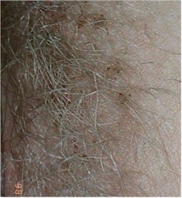
Ideally, the patient is examined with good lighting and a magnifying lens. The lice can be seen moving along the shafts of the pubic hair. Individual "nits" can be seen. These are small, oval, gray eggs attached to the hairs. Brown discolorations of the skin, when closely examined, are seen to contain lice excrement deposited just beneath the skin.

Without magnification, the brown spots can be seen, but most noticeable is the movement of the lice.

Treatment may include:
- Nix cream (5% permethrin) applied to the vulvar skin and left in place for 6-12 hours before washing off.
- Kwell lotion or shampoo (1% lindane) once after showering and left in place for 10 minutes before rinsing. This may be repeated in 7 days if necessary. Do not use more often or longer than this as lindane has neurotoxicity potential.
- Mechanically removing nits and lice by combing the pubic hair with a fine toothed comb.
- Clothing and bed linens should be thoroughly washed and dried. Mattresses should be aired or vacuumed. Sources of cross-contamination (shared clothing, towels) eliminated. Sexual contacts should be treated.

If conventional medication is not available, petroleum jelly, applied to the affected area may prove effective by suffocating the lice.

Primary Syphilis The distinguishing symptom is a painless ulcer on the vulva, vagina or cervix. The ulcer is non-tender, has a well-defined border and smooth base. It starts as a macular lesion, forms a central papule, then erodes to form an ulcer crater. Regional lymph nodes are enlarged, firm, mobile, and painless.
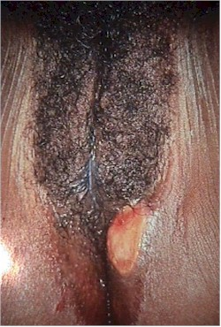
The diagnosis is confirmed by darkfield examination of serous fluid from crater (looking for spirochetes), a VDRL or RPR test.

Watch for the Herxheimer reaction beginning within a few hours of treatment, with fever, chills, malaise, headache and myalgia. It is treated with bedrest and aspirin and will disappear within 24 hours. Continue treatment.

Optimal treatment is:
- penicillin G 2.4 million units IM in a single dose

For those allergic to penicillin, you may substitute:
- Doxycycline 100 mg orally twice a day for 2 weeks, or
- Tetracycline 500 mg orally four times a day for 2 weeks.

If the patient is pregnant, tetracyclines should not be used. Should the pregnant patient also be allergic to penicillin, desensitization is recommended by many, but operational circumstances may not allow for that. In such cases erythromycin or Azithromycin can be effective, although the optimal dosage is unknown. The main concern here is that if insufficient antibiotic gets across the placenta and to the fetus, fetal syphilis will be insufficiently treated.

Runner's Rash Irritation or chafing from running or other vigorous, prolonged exercise.
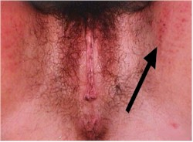
Skin of the inner thigh is reddened, excoriated, and may be bleeding in severe cases.

Treatment is local therapy, keeping the area clean, dry, and untraumatized by continued exposure to rubbing.

Prevention consists of:
- Avoiding cotton underwear when engaged in vigorous, repetitive physical activity. It gets wet and soggy, becoming an abrasive mass that wears away at the skin.
- Use petroleum jelly to lubricate the area while running

Scabies Scabies is a skin infection with small (1/2 mm) mites, Sarcoptes scabiei.

The mites burrow into the skin, laying their eggs in a trail behind them. About a month after the infection, there is a hypersensitivity skin reaction, with raised, intensely itchy skin lesions, most noticeable at night.
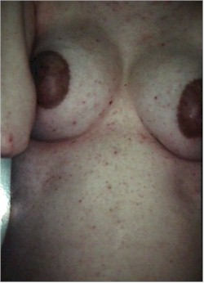

The burrows (tunnels) from the mites can be seen through the skin as thin, serpentine, scaly lines of up to 1 cm in length. They are most commonly found in the fingerwebs, elbows, axilla, and inner surface of the wrists. They are also seen commonly on the breast areolae of women and along the belt line and genitals of men.

The infection is spread by skin-to-skin contact with an infected person.

The diagnosis is made by visualizing a burrow and confirmed by microscopic visualization of the mite, ova or fecal pellets in scrapings of the burrow suspended in oil.

Treatment is:
- 5% permethrin cream (Nix, Elimite) applied to the skin from the neck down and left in place for 10 to 14 hours before washing off. Itching may persist for up to one month and should not be viewed as an indicator of failed treatment.
- If permethrin is not available, 1% lindane(Kwell lotion or shampoo) once after showering and left in place for 10 minutes before rinsing. This may be repeated in 7 days if necessary. Do not use more often or longer than this as lindane has neurotoxicity potential.
- Diphenhydramine 25-50 mg PO every 6 hours will relieve some of the itching, but will make the patient sleepy.
- In severe cases, Prednisone 40 mg PO QD X 2 days, then 20 mg X 2 days, then 10 mg X 2 days will provide significant relief. This regimen should be used cautiously in operational environments as it will suppress the immune system, making the patient more vulnerable to other problems.

Unlike pubic lice, Sarcoptes scabiei do not live long on clothing or bed linens.

Skene's Gland A Skene's gland is on each side of the urethral opening. It is normally neither seen nor felt, although close inspection will reveal the pinpoint openings of these periurethral glands.
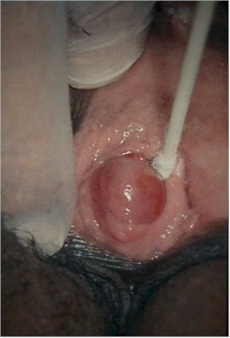
When infected, the Skene's gland will become enlarged and tender.

A simple incision and drainage of the gland will generally result in complete resolution. Topical anesthetic (20% benzocaine, or "Hurricaine") can be applied to the cyst with a cotton-tipped applicator and allowed to sit for 3-4 minutes. A single stab wound by a scalpel opens the abscess and allows for drainage of the pus.

Cultures, particularly for gonorrhea, should be obtained.

While in a civilian setting, antibiotics would be optional (pending culture results), they are very helpful in an operational settings. Good choices for antibiotics would include those most helpful for treating urethritis:
- Cefixime 400 mg orally in a single dose, OR
- Ceftriaxone 125 mg IM in a single dose, OR
- Ciprofloxacin 500 mg orally in a single dose, OR
- Ofloxacin 400 mg orally in a single dose,
PLUS
- Azithromycin 1 g orally in a single dose, OR
- Doxycycline 100 mg orally twice a day for 7 days.

Tinea Cruris (Jock Itch) A raised, reddened, intensely itchy lesion in the areas of skin to skin contact in the groin is characteristic of Tinea Cruris, which is also known as "Jock Itch." It is caused by a fungal infection.
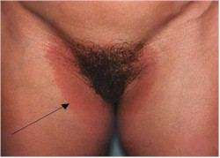
The diagnosis can be made on the basis of the typical appearance of the lesion, but can be confirmed by scraping the margin of the lesion and suspending the scrapings in KOH. A microscopic exam will reveal the typical threads of fungus.

Treatment is any conventional anti-fungal agent. If topical treatments are used, it may take up to several weeks to achieve a cure, even when applied two or three times a day. The fungus resides beneath the keratinized layer of skin and it takes time and persistence for the anti-fungal agent to penetrate through the skin to get at the fungus.

Prevention involves avoiding the predisposing factors of heat and moisture.

VIN Vulvar Intraepithelial Neoplasia (VIN) is a premalignant condition, which if untreated can lead to invasive cancer of the vulva.

In the cervix, premalignant changes occur (CIN I, II and III) which precede the development of invasive cancer by many months or years.
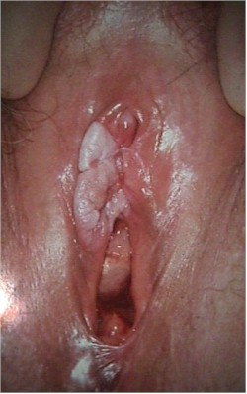
In the case of the vulva, the same principle applies, that there are premalignant changes, which may ultimately lead to cancer of the vulva. The degree of change is similarly labeled, VIN I, VIN II and VIN III (also known as "carcinoma-in-situ).

Clinically, these patient usually present with vulvar itching which does not respond to anti-fungal agents. Closer inspection visually will show the skin to have a white discoloration, which can be enhanced with the application of acetic acid.

Milder forms of VIN may not be obvious visually and special testing, such as the use of Toluidine Blue staining, may be necessary to identify the area of abnormality.

The diagnosis is confirmed with vulvar biopsy.

Treatment involves local excision, or in selected cases, laser vaporization. Close follow-up is very important should there be persistence or recurrence of disease.

Vulvar Cancer This erosive lesion is malignant and can present as vulvar bleeding from a friable external lesion. In it's more advanced form, it may ulcerate through the vaginal, rectal and bladder mucosa.

Effective treatment requires the skills of a definitive care center.

Vulvar Hematoma A vulvar hematoma is usually the consequence of a "straddle" injury. When a woman falls while straddling a fixed structure, such as chair, railing, sawhorse or fire hydrant, it is a common occurrence that the peri-clitoral vessels on one side or the other will be crushed against the pubic bone. This results in a vulvar hematoma.

Most of the vulvar enlargement is soft tissue swelling, but some is due to an encapsulated hematoma.
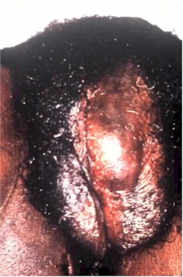

Diagnosis is made on the basis of history of a fall and the typical physical findings of unilateral swelling and pain.

Clinical management consists of:
- An icepack is placed over the perineum and left in place for 24-48 hours. This will help control the pain and limit swelling and further bleeding into the hematoma.
- A Foley catheter is inserted and left in place. The local swelling may be sufficient to impair voluntary voiding and the Foley is much easier to insert earlier in the process.
- Bedrest for several days to a week.
- Appropriate analgesia. Initially, this may need injectable narcotics. Later, oral narcotics and then NSAIDs will give satisfactory results.
- Dramatic resolution will occur. When completely healed in a few weeks, the vulva will look normal and function normally.
- Most of these hematomas will not require surgical exploration and drainage. If you explore them, in about half the cases, no bleeding point will ever be found. Opening them introduces bacteria into an otherwise sterile hematoma. Particularly in operational settings, ice, Foley and bedrest are usually better choices for treatment.

In following these, it may prove useful to measure the hematoma with a tape measure to compare the size over time. As they are feeling less pain, patients will often feel that the hematoma is enlarging. Having objective measures of its' size will be very reassuring to the patient.

Vulvar Dystrophy Vulvar dystrophy is the abnormal growth of the skin of the vulva, in a benign but symptom-provoking manner.

There are two forms of vulvar dystrophy:
- Lichen sclerosis, in which the skin of the vulva is too thin, and
- Hypertrophic vulvar dystrophy, in which the skin of the vulva is growing too thick.

A third form, mixed dystrophy, is a combination of both.

Both forms are associated with vulvar itching (pruritus) and burning, not responsive to anti-fungals, antibiotics or other creams or salves. Both can cause a white discoloration of the skin.

While very experienced examiners may be able to predict which form of vulvar dystrophy is present in a patient, based on observation alone, a vulvar biopsy is usually needed to confirm the diagnosis.

<big>Vulvar Vestibulitis </big>Vulvar vestibulitis is a condition of uncertain cause, characterized by pain and burning in specific sites on the vulva.

The pain is most noticeable during intercourse and is very consistent, both in character and location.

The pain and tenderness is distributed in a U-shaped pattern around the introitus and includes the hymeneal remnants and up to 1 cm of skin exterior to the hymen. Visually, the tender areas are reddened and touching them gently with a cotton-tipped applicator will duplicate the pain they experience during intercourse (a positive "Q-Tip Test"). Biopsy of these tender areas will show a generalized inflammatory pattern of non-specific etiology.

Some women with vestibulitis indicate they have always felt this discomfort during intercourse. Others seem to have acquired the condition. They have painless intercourse initially, and later develop the painful intercourse so characteristic of this condition.

The diagnosis is based on the physical examination, with persistent areas of tenderness to touch, located in the U-shaped area surrounding the hymenal ring. Biopsy is neither necessary nor often done.

Treatment is problematic. Antibiotics, anti-fungals, anti-virals, estrogens, and steroids are often used and are often found to be ineffective. Antioxalates (used with the theory that oxalates provoke a skin reaction in this area) are promoted by some, but randomized studies demonstrate them to be no better than placebo.

Several studies have demonstrated the efficacy of surgical excision of the affected area (perineoplasty) in selected cases..

Yeast (Candida, Monilia) Vaginal yeast infections are common, monilial overgrowths in the vagina and vulvar areas, characterized by itching, dryness, and a thick, cottage-cheese appearing vaginal discharge. The vulva may be reddened and irritated to the point of tenderness.

These infections are particularly troublesome in operational settings where they are both frequent and annoying. Yeast thrives in damp, hot environments and women in such circumstances are predisposed toward these infections. Women taking broad-spectrum antibiotics are also predisposed towards these infections because of loss of the normal vaginal bacterial flora.
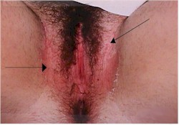

Yeast organisms are normally present in most vaginas, but in small numbers. A yeast infection, then, is not merely the presence of yeast, but the concentration of yeast in such large numbers as to cause the typical symptoms of itching, burning and discharge. Likewise, a "cure" doesn't mean eradication of all yeast organisms from the vagina. Even if eradicated, they would soon be back because that is where they normally live. A cure means that the concentration of yeast has been restored to normal and symptoms have resolved.
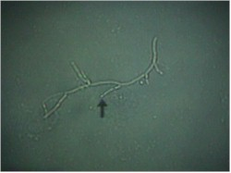
The diagnosis is often made by history alone, and enhanced by the classical appearance of a dry, cheesy vaginal discharge. It can be confirmed by microscopic visualization of clusters of thread-like, branching Monilia organisms when the discharge is mixed with KOH.

Treatment consists of an oral antifungal agent,
- Fluconazole 150 mg oral tablet, one tablet in single dose,
or intravaginal agents:
- Butoconazole 2% cream 5 g intravaginally for 3 days
- Clotrimazole 1% cream 5 g intravaginally for 7-14 days
- Clotrimazole 100 mg vaginal tablet for 7 days
- Clotrimazole 100 mg vaginal tablet, two tablets for 3 days
- Clotrimazole 500 mg vaginal tablet, one tablet in a single application
- Miconazole 2% cream 5 g intravaginally for 7 days
- Miconazole 200 mg vaginal suppository, one suppository for 3 days
- Miconazole 100 mg vaginal suppository, one suppository for 7 days
- Nystatin 100,000-unit vaginal tablet, one tablet for 14 days
- Tioconazole 6.5% ointment 5 g intravaginally in a single application
- Terconazole 0.4% cream 5 g intravaginally for 7 days
- Terconazole 0.8% cream 5 g intravaginally for 3 days
- Terconazole 80 mg vaginal suppository, one suppository for 3 days.

If none of these products are available, douching with a weak acid solution (2 teaspoons of vinegar in a quart of warm water) twice a day will help restore an acid pH to the vagina, inhibiting yeast proliferation. Stop douching when symptoms have resolved as the douche itself tends to remove some of the protective mucous within the vagina.

Whenever the skin of the vulva is involved, more frequent treatment for a longer period of time may be necessary.

Reoccurrences are common and can be treated the same as for initial infections. For chronic recurrences, many patients find the use of a single applicator of Monistat 7 at the onset of itching will abort the attack completely. Sexual partners need not be treated unless they are symptomatic.

<TBODY>

