Operational Obstetrics & Gynecology

The Health Care of Women in Military Settings

2nd Edition

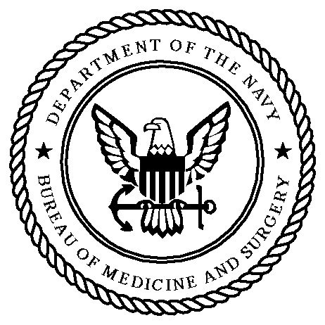

CAPT Michael John Hughey, MC, USNR

Special Projects Officer for the Assistant Chief,
Operational Medicine and Fleet Support
Bureau of Medicine and Surgery
Department of the Navy
2300 E Street NW
Washington DC
20372-5300

