Problems During Labor and Delivery

Preterm Labor Most labors occur within 2 weeks of the due date. Labor occurring prior to the 38th week of pregnancy is preterm labor, although definitions vary depending on the clinical circumstances.

While delivering a little bit early usually poses no particular problem for the mother or the baby, more significant amounts of prematurity pose more significant risks for the infant. Of these, immaturity of the respiratory tree is among the most hazardous, but other organs can also be a problem.

The cause of preterm labor is unknown, but in about half the cases, it is associated with detectable intrauterine infection. Another significant number are associated with placental abruption.

Our instincts are to try to prevent preterm delivery to avoid the morbidity associated with it. This instinct is based on the premise that the problem is primarily one of prematurity. If, however, preterm labor in a particular patient is just a symptom of an underlying problem (infection, fetal stress, etc.), then vigorous attempts to prevent delivery, when successful, may only delay treatment of the underlying problem. Further, the medications commonly used to prevent premature delivery have significant side effects and risks. For these reasons, judgment is used to decide who should be treated for preterm labor and who shooed be allowed to deliver. In many civilian hospitals, no attempt is made to arrest labor after the 34th week.

Threatened preterm labor consists of regular, frequent contractions (every 10 minutes) that do not lead to a change in the cervix. In many civilian hospitals, it is customary to withhold any labor-stopping medication until cervical change is noted. These civilian hospitals also have abundant resources to treat preterm labor and premature infants should labor unexpectedly progress rapidly. In an operational setting, such resources may not be available and earlier treatment may be indicated.

In military settings, it is often helpful to postpone delivery long enough to get the patient to a definitive care setting, even if the patient is more than 34 weeks gestation. It is best to coordinate the use of these medications with the receiving facility. Any of the following treatments may effectively disrupt the labor process for 24-48 hours, and this is usually long enough to move the patient to an area of greater resource.
- Magnesium sulfate, 4 gm loading dose over at least 5 minutes, followed by 2 gm/hour in a steady IV drip. Watch for magnesium toxicity with diminished reflexes and respiratory depression, and treated with calcium.
- Ritodrine (Yutapar) 100 µg/minute IV, increased every 15 minutes by 50 µg to a maximum of 350 µg/min. Titrate dosage to a maternal pulse of not less than 100 BPM and not greater than 120 BPM. Watch for pulmonary edema in the mother.
- Terbutaline 0.25 mg SQ, every 1-4 hours x 24 hours, total dose not to exceed 5 mg in 24 hours. May also be given PO in 2.5 - 7.5 mg doses, every 1.5 - 4 hours. Target maternal pulse rate is > 100 and < 120 BPM
- Indomethacin (Indocin), 50 mg PO (or 100 mg PR), followed by 25 mg PO every 4-6 hours for up to 48 hours. Watch for gastric bleeding, heartburn, nausea and asthma.
- Nifedipine, 10 -20 mg PO every 4-6 hours (Watch for headache, flushing and nausea).

While postponing delivery, many fetuses less than 34 weeks gestation will benefit from administering steroids to the mother. The effect of the steroids on the fetus is to accelerate fetal pulmonary maturity, lessening the risk of respiratory distress syndrome of the newborn. Appropriate doses include:
- Betamethasone 12 mg IM, and repeated in 24 hours.
- Dexamethasone 6 mg IM Q 12 hours x 4 doses.

When transporting the mother to a definitive care setting, have her remain way over on her left or right side, with a pillow between her knees, and an IV securely in place. If IV access is lost during a bumpy truck or helo ride, it will be nearly impossible to restart it without stopping or landing.

Premature ROM Most women will rupture their membranes during labor. If membranes rupture prior to the onset of labor, this is called premature rupture of the membranes, or PROM.

The obstetrical significance of PROM is that labor needs to begin promptly or infection will develop with bacteria ascending through the birth canal. In some cases of PROM, the reason the membranes rupture prematurely is because there is an established infection, which has weakened the membranes.

If the pregnancy is at full term and there is no evidence of infection, no treatment is necessary initially, because most women will go into spontaneous labor within the next 6 hours. After 6 hours of rupture, or in the face of infection or other pressing clinical circumstance, labor can be induced. Unless infection is evident, antibiotics are not helpful.

When PROM occurs remote from term, two basic approaches can be taken...induce labor or wait for the fetus to mature further. There are pros and cons to each approach and the decision will hinge on individual clinical circumstances. This decision is best made in consultation with a definitive care facility.

Confirmation of PROM is optimally made via a sterile speculum examination, looking for pooled amniotic fluid in the vagina, Nitrazine positive fluid, ferning positive fluid, and to obtain a culture of the fluid.

Abnormal Presentation A fetus in transverse lie cannot deliver vaginally and requires a cesarean section to avoid uterine rupture during labor. Some of these women will also have a placenta previa (as the cause of the transverse lie). Others will need an urgent cesarean because of prolapsed cord. Without the fetal head or butt occupying the birth canal, it is relatively easy for an umbilical cord to prolapse through a widely dilated cervix with ruptured membranes.

A compound presentation may be resolvable if the fetus can be encouraged to withdraw the hand, for example.

If the fetus and arm are relatively small in comparison to the maternal pelvis, vaginal delivery may still be possible, but with some risk of injury to the arm.

The bones of the fetal scalp are soft and meet at "suture lines." Over the forehead, where the bones meet, is a gap, called the "anterior fontanel," or "soft spot." This will close as the baby grows during the 1st year of life, but at birth, it is open.

The anterior fontanel is an obstetrical landmark because of its' distinctive diamond shape. Feeling this fontanel on pelvic exam tells you that the forehead is just beneath your fingers.

The occiput of the baby has a similar obstetric landmark, the "posterior fontanel." This is a junction of suture lines in a Y shape that is very different from the anterior fontanel.

In cases of fetal scalp swelling or significant molding, these landmarks may become obscured, but in most cases, they can identify the fetal head position as it is engaged in the birth canal.

The fetal position is usually described using three letters. LOA means the fetal occiput is directed towards the mother's left, anterior (front) side. ROT means right occiput anterior. These anterior presentations are normal and usually are the easiest way for the fetus to traverse the birth canal.

LOT (Left, Occiput, Transverse) position and its' mirror image, ROT, are common in early labor. As labor progresses and the fetal head descends, the occiput usually rotates anteriorly, converting this LOT to an LOA or OA as the head delivers. If the head fails to rotate despite steady descent, this is called a "deep transverse arrest," and is common among:
- Babies who are too big to come through, and
- Mothers with flat pelvises that favor a transverse delivery
Women with this condition who fail to deliver spontaneously are treated with cesarean section, forceps, or vacuum extraction, depending on the clinical circumstances, available resources, and experience of the operator.

LOP (Left Occiput Posterior) and ROP (Right Occiput Posterior) are positions favored by certain internal pelvic shapes. This position has some obstetrical significance.
- Normally, if the head is at 0 Station, the biparietal diameter is at the pelvic inlet and the head is fully engaged. In posterior positions, at 0 Station, the biparietal diameter is still a couple centimeters above the pelvic inlet, meaning that the head is not fully engaged.
- Babies can deliver in the posterior position, but the pelvis needs to be large enough and it usually takes longer.
- Forceps are often used to deliver babies in this position, but there is controversy whether the fetus should be delivered in the posterior position, or rotated with the forceps to the anterior position. Much depends on the clinical circumstances and the experience of the operator.

Prolonged Latent Phase Labor Latent phase labor lasting longer than 20 hours in a woman having her first baby or more than 14 hours in other women is considered a "prolonged latent phase."

Women with a prolonged latent phase risk exhaustion and an increased risk of uterine infection (chorioamnionitis).

No single treatment of prolonged latent phase will necessarily be successful in nudging the patient into active phase labor, but each of the following have been successful in many patients:
- Rest
- Ambulation
- Hydration
- Analgesia (narcotics such as Demerol 50-100 mg IM, Morphine 7.5-15 mg IM, Dilaudid 1-2 mg IM, etc.)
- Oxytocin stimulation

Arrest of Active Labor Normal labor progresses at a rate of no less than 1.2 cm/hour (for first babies) to 1.5 cm/hour (for subsequent babies). If active labor progresses more slowly than this, an "arrest of labor" has occurred.

The arrest of labor may be simple slowing of the labor below the expected rate, or may represent a complete arrest, in which there is no further progress for at least 2 hours.

There are essentially only two causes for an arrest of labor:
- Inadequate contractions, or
- Mechanical impediment to the progress of labor.

Contractions may be inadequate because they are too infrequent (more than 4 minute intervals), or do not last long enough (less than 30 seconds). Often in this situation, they are neither frequent enough nor long enough.

Mechanical impediments to labor may include:
- Absolute feto-pelvic disproportion, in which the maternal pelvis is not large enough to allow the baby to pass through the birth canal.
- Relative feto-pelvic disproportion, in which there is a snug fit, but given time and adequate contractions, the baby can safely negotiate the birth canal
- Fetal malposition, in which the fetal head is presenting in a less favorable position (for example, occiput posterior, or with fetal hand preceding the head, or a transverse lie)
- Asynclitism, in which the fetal head is angled slightly to one side, making it more difficult for a clear passage through the birth canal.

Inadequate contractions are treated with uterine stimulation. This is generally accomplished with intravenous oxytocin, delivered in steady, small amounts with a controlled infusion pump. The dose is started relatively low, and then advanced gradually until the desired effect is achieved. Later in labor, the dosage is often adjusted downward or stopped altogether if the contractions are too close together (consistently more than 5 contractions every 10 minutes).

In an operational setting where a controlled infusion pump is not available, two other options can be employed:
- 10 units of oxytocin are put in a 1-liter IV. With one hand on the maternal abdomen to palpate uterine contractions, the other hand adjusts to flow rate of the IV. Initially, just a few drops are infused and the effect assessed. If the patient shows no unusual degree of sensitivity, the IV flow rate is gradually increased until the desired effect is obtained. This will often take 45 minutes to an hour of careful adjustment.
This technique is not as safe as a controlled infusion pump, but it is still safe enough to be used if the need for oxytocin is great and the resources are limited.

A common occurrence with this technique is overstimulation of the uterus resulting in a prolonged, tetanic contraction. Usually this will resolve with time, but occasionally it is so severe as to cause a uterine rupture. For that reason, careful monitoring of the fetus during this application of oxytocin is very important and immediate availability of surgical resources is very desirable.
- Nipple stimulation (rolling the nipple back and forth with thumb and forefinger) will cause of release of the mother's own oxytocin from her pituitary gland. This will have the effect of stimulating contractions. Stimulating both nipples will have about double the effect as stimulating one nipple. After about 15-20 minutes of nipple stimulation you will have released about as much natural oxytocin as is available. Nipple stimulation can be repeated at a later time, after the natural oxytocin supply has been replenished.
While this technique can be effective, the biggest problem is overstimulation of the uterus because of too much oxytocin. Rather than achieving more frequent, longer contractions, you will end up with a single, 3-5 minute contraction that is threatening to the fetus and the integrity of the uterus. With that warning in mind, if the need is great and resources are limited, nipple stimulation can be effective in stimulating labor.

Start with stimulation of just one nipple. Have the mother perform this on herself. It usually takes 3-5 minutes of this before you will notice any effect on the uterus. If gentle nipple stimulation is not effective, increase the strength of the nipple massage. If there is still no result, you can try stimulating both nipples. Just make sure to give the uterus enough time to respond.
The possibility of a mechanical impediment should be considered whenever arrest disorders occur.
- If the fetus is in a transverse lie, it will not be able to deliver vaginally and continuing labor will ultimately lead to uterine rupture.
- If the fetus is in an occiput posterior position, vaginal delivery may still be successful, but it will take longer.
- If the fetus is a little large for the birth canal, vaginal delivery may still be successful, but only with time and fetal molding to the shape of the pelvis.
- If there is a compound presentation (head and hand, for example), the baby may still come through, but it may take much longer. (Try pinching the hand to see if the fetus will react by pulling it up and out of the way.)

Usually, there is no way to know in advance which labors will experience an absolute obstruction and those that will not. For this reason, a trial of labor is almost always indicated. Those patients with an absolute obstruction will demonstrate a complete arrest pattern and will need cesarean section.

Shoulder Dystocia Shoulder dystocia means difficulty with delivery of the fetal shoulders. Although this is more common among women with gestational diabetes and those with very large fetuses, it can occur with babies of any size. Unfortunately, it cannot be predicted or prevented.

After delivery of the head, the fetus seems to try to withdraw back into the birth canal (the "Turtle Sign"). Digital exam reveals that the anterior shoulder is stuck behind the pubic symphysis. In more severe cases, the posterior shoulder may be stuck at the level of the sacral promontory.

Excessive downward traction, applied to try to get the baby out, can lead to injury to the nerves in the neck and shoulder (brachial plexus palsy) and should be avoided. While most of these nerve injuries heal spontaneously and completely, some do not.

A generous episiotomy can be helpful. If a spontaneous laceration has occurred, or if the perineum is very stretchy and offers no obstruction, it is not necessary to also perform an episiotomy.

Gentle downward traction can be attempted initially to try to free the shoulder.

If this has no effect, do not exert increasing pressure. Instead, try some alternative maneuvers to free the shoulder.
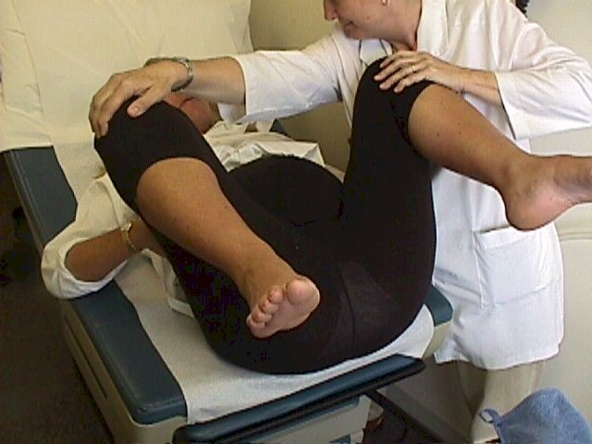
The MacRobert's Maneuver involves flexing the maternal thighs tightly against her abdomen. This can be done by the woman herself or by assistants. By performing this maneuver, the axis of the birth canal is straightened, allowing a little more room for the shoulders to slip through. While in the MacRobert's position, gentle downward traction can again be attempted.

Suprapubic pressure can be applied to drive the fetal shoulder downward, clearing the pubic bone. It is usually easiest to have an assistant apply this downward pressure while the birth attendant applies coordinated, gentle downward traction.


Sometimes, the suprapubic pressure is more effective if applied in a somewhat lateral direction, rather than straight down. This tends to nudge the shoulder into a more oblique orientation, which in general provides more room for the shoulder. Gentle downward traction on the fetal head in combination with this suprapubic pressure may relieve the obstruction.

Often, the posterior arm has entered the hollow of the sacrum. By reaching in posteriorly and sweeping the arm up and out of the birth canal, enough additional space will be freed to allow the anterior shoulder to clear the pubic bone.

This description makes the maneuver sound easier than it is. Because of limited visibility and space, this maneuver is sometimes difficult or impossible.

Identify the posterior shoulder and follow the fetal humerus down to the elbow. Then you can identify the fetal forearm. Grasping the fetal wrist, draw the arm gently across the chest and then out.

If you try to remove an electric light bulb by simply pulling it out, it won't work. If, however, you unscrew the light bulb, it comes out relatively easily. The concept of unscrewing the light bulb can be applied to shoulder dystocia problems.

This drawing shows the birth attendant pushing the posterior shoulder in a clockwise direction. As the shoulder rotates, it comes up outside of the subpubic arch. At the same time, the stuck anterior shoulder is brought posteriorly into the hollow of the sacrum. As the rotation continues a full 360 degrees, both shoulders are rotated (unscrewed) out of the birth canal.
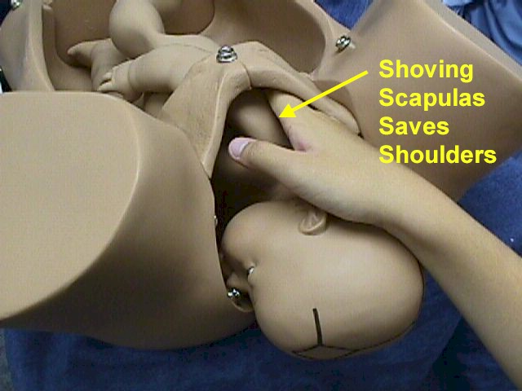
Applying fundal pressure in coordination with other maneuvers may, at times, be helpful. Applied alone, it may aggravate the problem by further impacting the shoulder against the symphysis.

Two variations on the unscrewing maneuver include:
- Shoving the shoulder towards the fetal chest ("shoving scapulas saves shoulders"), which compresses the shoulder-to-shoulder diameter, and
- Shoving the anterior shoulder rather than the posterior shoulder. The anterior shoulder may be easier to reach and simply moving it to an oblique position rather than the straight up and down position may be sufficient

Breech Delivery Breech babies can present in a variety of ways, including buttocks first, one leg or both legs first.

Frank breech means the buttocks are presenting and the legs are up along the fetal chest. This is the safest position for breech delivery.
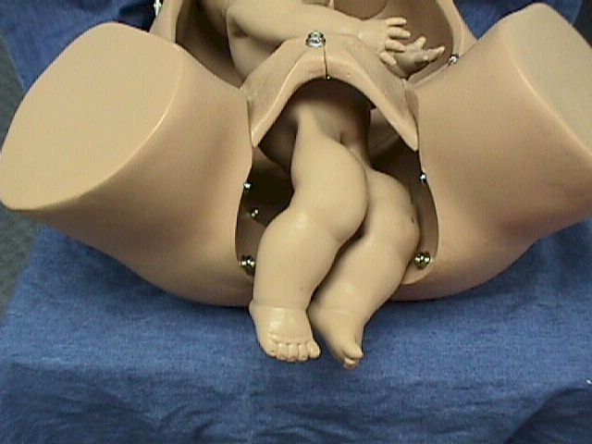
If either foot is presenting ("footling breech"), there are increased risks of umbilical cord prolapse and delivery of the feet through an incompletely dilated cervix, leading to arm or head entrapment.

Because of the risks of breech delivery, in many civilian hospitals most or all breech babies are born by cesarean section. In operational settings, cesarean section may not be available or may be more dangerous than performing a vaginal breech delivery.

The simplest breech delivery is called a spontaneous breech. The mother pushes the baby out with the normal bearing down efforts and the baby is simply supported until it is completely free of the birth canal. These babies pretty much deliver themselves. This works best with smaller babies, mothers who have delivered in the past, and frank breech presentation.

If the breech baby gets stuck half-way out, or if there is a need to speed the delivery, an "assisted breech" delivery is performed. For this type of delivery, it is very helpful to have a second person to aid you. A generous episiotomy will give you more room to work, but may be unnecessary if the vulva is very stretchy and compliant.

Grasp the baby so that your thumbs are over the baby's hips. Rotate the torso so the baby is face down in the birth canal. A towel can be wrapped around the lower body to give the you a more stable grip.

Have your assistant apply suprapubic pressure to keep the fetal head flexed.
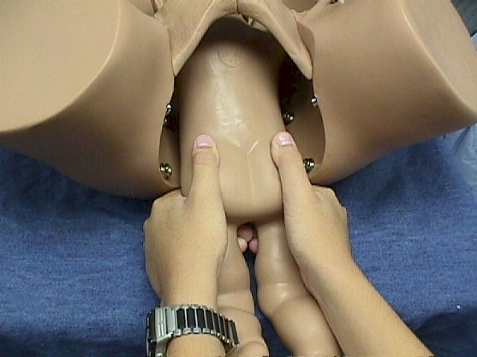

Exert gentle outward traction on the baby while rotating the baby first clockwise and then counterclockwise a few degrees to free up the arms. If the arms are trapped in the birth canal, you may need to reach up along the side of the baby and sweep them, one at a time, across the chest and out of the vagina.

It is important to keep you hands low on the baby's hips. If you grasp the baby above the hips, it is relatively easy to cause soft tissue injury to the abdominal organs, including the kidneys.
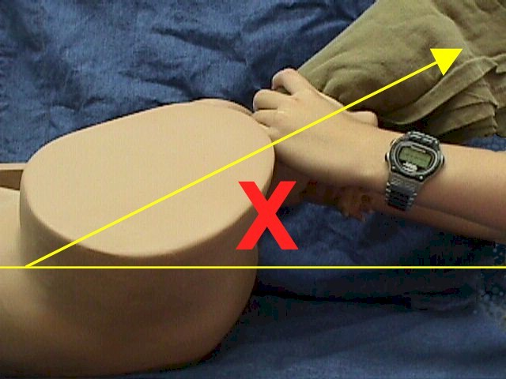

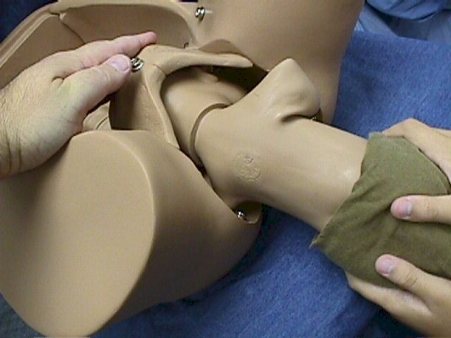
During the delivery, always keep the baby at or below the horizontal plane or axis of the birth canal. If you bring the baby's body above the horizontal axis, you risk injuring the baby's spine. Only when the baby's nose and mouth are visible at the introitus is it wise to bring the body up.

The application of suprapubic pressure by the assistant is important for keeping the head flexed against the chest, expediting delivery, and reducing the risk spinal injury. At this stage, the baby is still unable to breathe and the umbilical cord is likely occluded. Without rushing, move steadily toward a prompt delivery. Placing your finger in the baby's mouth may help you control the delivery of the head.

Try not to let the head "pop" out of the birth canal. A slower, controlled delivery is less traumatic.

Twin Delivery About 40% of twins present as cephalic/cephalic. The remainder pose some abnormal presentation of one or both twins. Because of the abnormal presentations and the complexities of delivering twins, many are delivered by cesarean section in civilian settings. Some physicians favor cesarean delivery for all twins. In many operational settings, this approach may not be available or wise, and vaginal delivery may be performed.

Following delivery of the first twin, there is a period of time during which contractions slow or stop. Both placentas remain inside the uterus and attached. It is usually safest to make no attempt to speed up this process, but to await the resumption of contractions. This could take a few minutes or many minutes. While waiting, monitor the second twin's heart beat and if normal, continue to observe the patient.

If contractions do not promptly resume, it is acceptable to stimulate the uterus with oxytocin.

With your hand in the vagina, feel the fetal presenting part. If it is not engaged, try to guide it down to the pelvic inlet. Avoid rupturing membranes until the fetal presenting part is engaged in the birth canal.

As the presenting part descends, ask the mother to bear down and usually the second twin will deliver as easily as the first twin will. First twins are usually bigger than their siblings are.

Prolapsed Umbilical Cord If a portion of the umbilical cord comes out of the cervix or vulva ahead of the fetus, this is called a prolapsed umbilical cord.

This can be a big problem for the fetus if the cord is compressed, blocking the flow of blood to the baby.

Immediate delivery is the best solution to this problem. If immediate delivery is not available, put the mother in the knee-chest position and use your hand in her vagina to elevate the fetal head back up into the uterus. This action may relieve enough pressure on the umbilical cord that oxygen can still get through to the baby. Transport the mother in the knee-chest position and you with your hand elevating the fetal presenting part to the nearest facility in which immediate delivery is possible.

Cord Around the Neck This is a frequent occurrence during delivery. Nearly half of babies have the umbilical cord wrapped around something (neck, shoulder, arm, etc.), and this generally poses no particular problem for them.

In a few cases, the cord will be wrapped so tightly around the baby's neck (after delivery of the head but before the shoulders are delivered) that you cannot get the rest of the baby out without risk of tearing the umbilical cord.
- If you can easily slip the cord over the baby's head, go ahead and do that.
- If the cord is relatively loose, and allows the baby to be born with the cord around its' neck, go ahead and do that.
- If the cord is tight and disallows any manipulation, double clamp the cord and cut between the clamps. This will free the cord. With this approach, prompt delivery of the rest of the baby is important.

Retained Placenta After delivery of the baby, the placenta will detach from the inside of the uterus and will be expelled, often with additional pushing efforts by the mother. Normally this occurs within a few minutes of delivery of the baby, but may take as long as an hour.

Often after about 30 minutes of waiting, a manual removal of the placenta is undertaken. Anesthesia (regional or general) is typically used for this as manual removal causes a great deal of abdominal cramping. In operational settings, if necessary, it may be performed without anesthesia or with some IV narcotic analgesia.

One hand is inserted through the introitus and into the uterine cavity. Grasp the edge of the placenta and use the side of your hand to sweep the placenta off the uterus. Then pull the placenta through the cervix. Most placentas can be easily and uneventfully removed in this way. A few prove to be problems.

When you manually remove the placenta, be prepared to deal with an abnormally adherent placenta (placenta accreta or placenta percreta). These abnormal attachments may be partial or complete.
- If partial and focal, the attachments can be manually broken and the placenta removed. It may be necessary to curette the placental bed to reduce bleeding. Recovery is usually satisfactory, although more than the usual amount of post partum bleeding will be noted.
- If extensive or complete, you probably won't be able to remove the placenta in other than handfuls of fragments. Bleeding from this problem will be considerable, and the patient will likely end up with multiple blood transfusions while you prepare her for a life-saving, post partum uterine artery ligation or hysterectomy. If surgery is not immediately available, consider tight uterine and/or vaginal packing to slow the bleeding until surgery is available.

Post Partum Hemorrhage Average blood loss following a delivery is about 500 cc. Bleeding that is significantly in excess of that is considered post partum hemorrhage.

Most cases of post partum hemorrhage are caused by the uterus not contracting firmly after delivery. In some cases, there is a retained blood clot inside the uterus, which disallows a firm, tight contraction. Manually expressing the blood clot by squeezing the fundus will usually control bleeding from this source.

Uterine massage is an immediate treatment, often very effective, in stopping the bleeding. Oxytocin can be added:
- Oxytocin 20 units in 1 liter of IV fluids, run briskly (wide open) for a few minutes will flood the mother with a strong uterotonic agent.
- Oxytocin 10 units IM will take longer to be effective, but will have a more sustained action and is immediately available without an IV.
- Methylergonovine maleate 0.2 mg IV or IM will firmly contract the uterus, but should be used cautiously if at all in women with pre-existing hypertension.
- Prostaglandin F-2-alpha can be effective but is rarely available in operational settings.

Bimanual compression of the uterus is an effective way of slowing or stopping the bleeding associated with post partum hemorrhage.
The uterus is elevated out of the pelvis by the vaginal hand, and compressed against the back of the pubic bone by the abdominal hand.

Blood transfusion may be life saving in some of these patients.

In a non-pregnant patient, progressive hypovolemia is usually accompanied by the predictable signs of tachycardia, hypotension and tachypnea before confusion and loss of consciousness occur. Women with immediate post partum hemorrhage do not necessarily follow that path and may look surprisingly well until they collapse. Because of this, your decision to give or not give blood to these women should depend heavily on your estimated blood loss, clinical circumstances and likelihood of continuing blood loss, and less on her vital signs. Women who quickly lose half their blood volume (2500 out of 5000 ml) usually benefit from transfusion.

In civilian settings, banked blood is usually given. In many operational settings, banked blood is not available and fresh, whole blood will be used.

Chorioamnionitis Chorioamnionitis is an infection of the placenta and fetal membranes.

In its' earliest stage, there may be no symptoms or clinical signs. As it becomes more advanced, clinical evidence of infection may appear, including:
- Elevated maternal temperature above 100.4.
- Elevated maternal white blood count
- Fetal tachycardia
- Foul-smelling amniotic fluid
- Uterine tenderness

Chorioamnionitis may be a problem for both the mother and the fetus. Maternal infections can prove to be very serious. The fetus may suffer not just from infection, but also because of the elevated core temperature of the mother. Increased core temperatures lead to an increased metabolic rate of the fetal enzyme systems, which in turn need more oxygen than normal. At times, this increased oxygen demand cannot be met and the fetus may become progressively acidotic.

Chorioamnionitis during labor is usually treated very aggressively, with broad-spectrum, intravenous antibiotics such as:
- Ampicillin 2 gm IV every 6 hours, plus gentamicin 1.5 mg/kg (loading dose) and 1.0 mg/kg every 8 hours
- Ampicillin/sulbactam 3 gm IV every 4-6 hours
- Mezlocillin 4 g IV every 4-6 hours
- Piperacillin 3-4 g IV every 4 hours
- Ticarcillin/clavulanic acid 3.1 gm IV every 6 hours

Maternal temperature is treated with oral or rectal acetaminophen, 1 gm every 4 hours. Plans are made for prompt delivery.

Group B Streptococcus GBS is a source of significant morbidity and sometimes mortality. Many women are asymptomatic carriers.

A variety of schemes to reduce perinatal GBS infections have been proposed and used in different civilian settings. In operational settings, once good way of dealing with this issue is to treat on the basis of risk factors.

Using this approach, women with any of the following risk factors are treated for possible GBS:
- Previous infant with invasive GBS disease
- Documented GBS bacteruria during this pregnancy
- Delivery at <37 weeks gestation
- Ruptured membranes 18 hours or longer
- Fever during labor of 100.4 or greater

Treatment consists of:
- Penicillin G, 5 million units IV, followed by 2.5 million units IV every 4 hours until delivery, or
- Ampicillin 2 gm IV, followed by 1 gm IV every 4 hours until delivery, or
- Clindamycin 900 mg IV every 8 hours, or
- Erythromycin 500 mg IV every 6 hours until delivery, or
- Other broad-spectrum antibiotics if clinically indicated

Post Partum Fever Maternal febrile morbidity is classically defined as temperatures exceeding 100.4 on at least two occasions, at least 6 hours apart.

For patients with an obvious infection with high fever, localizing signs and septic in appearance, treatment is initiated prior to fulfillment of the 6-hour definition.

Cultures from the urine and vagina (and sometimes blood) can be useful in civilian settings. In operational settings, their value may be limited. Similarly, a chest x-ray, which might be ordered and promptly obtained in a civilian setting may not be available or of any practical value in a military setting.

Examine the patient, looking for localizing signs that will guide you in your therapy. Check for:
- Uterine tenderness, suggesting a uterine or endometrial source
- Flank tenderness, suggesting pyelonephritis
- Breast tenderness and redness, suggesting mastitis
- Perineum tenderness and redness, suggesting wound infection
- Pulmonary rales, rhonchi or wheezes, suggesting a respiratory source
- Calf tenderness, suggesting deep vein thrombophlebitis

If a specific source is identified, treatment specific for that source can be employed. However, in operational settings, there is considerable risk of multiple sources and vigorous antibiotic therapy is generally initiated. Good choices for such therapy include:
- Ampicillin 2 gm IV every 6 hours, plus gentamicin 1.5 mg/kg (loading dose) and 1.0 mg/kg every 8 hours, plus clindamycin 900 mg IV every 6 hours
- Ampicillin/sulbactam 3 gm IV every 4-6 hours
- Mezlocillin 4 g IV every 4-6 hours
- Piperacillin 3-4 g IV every 4 hours
- Ticarcillin/clavulanic acid 3.1 gm IV every 6 hours
- Cefotetan 1-2 g IV every 12 hours

