Other Contraceptive Methods

Condoms A condom is a latex or animal skin sheath, which fits over the penis. During orgasm, with ejaculation of semen, the sperm are trapped within the condom, preventing pregnancy.

The condom is very effective, with annual failure rates of about 2%. Reasons for failure include non-use, breakage of the condom during intercourse, or loss of the condom. This loss most often occurs after ejaculation as the penis is returning to its' non-erect size.
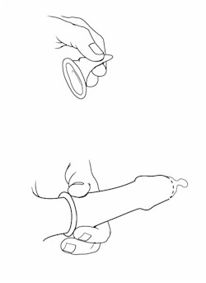

To prevent loss of the condom at this time, it is important to hold onto the base of it when the penis is withdrawn from the vagina. Making sure to roll the condom completely down (rather than partway down) over the erect penis will also help prevent its loss during intercourse. Use of high-quality, new condoms is also advisable. Tiny pinholes in the condoms are not likely to be a cause for failure and the process of checking for such tiny openings is likely to weaken the condom, increasing the chance for breakage.

Some condoms are pre-lubricated. While this makes them somewhat more difficult to put on (they are slippery), the lubrication increases their heat and surface contour conduction, making their use seem less "artificial," and improving sensitivity. For couples in whom vaginal lubrication is insufficient, lubricated condoms can be helpful. Use of petroleum jelly as a lubricant is probably not a good idea as latex is soluble in petroleum products and the lubricant may weaken the condom.

Some condoms are packaged with a spermicide (nonoxynol-9). This addition increases their effectiveness somewhat, but condoms are still considered about 98% effective. That is, 2 women out of 100 will become pregnant each year if condoms are used as contraception.

Some couples place the condom on the male just prior to his orgasm, but after considerable penetrative sexual activity has already taken place. To maintain a high level of effectiveness, the penis should not come in contact with the vulva or vagina prior to placement of the condom. During sexual arousal but prior to orgasm, a small amount of clear liquid may appear at the tip of the penis. This liquid can contain both sperm and STDs. If the penis were to enter the vagina at this time, both pregnancy and infection are possible, even though male orgasm has not yet occurred.

Some condoms have a reservoir tip to collect semen after ejaculation. Others have no such reservoir. For those condoms, it is a good idea to pinch the tip of the condom before applying it, creating an air-free space that can function as a reservoir tip.

In addition to providing contraception, the condom also provides reasonably good protection against some sexually transmitted diseases. The condom provides good protection against HIV, chlamydia, gonorrhea and syphilis...those STDs transmitted via semen or body fluids. The condom does not offer much protection against such STDs as condyloma (warts) or herpes, because these viruses are transmitted mainly through skin-to-skin contact and the condom does not totally cover all areas of intimate skin contact in the male. Nor does it cover all of the vulnerable tissues in women. Condoms are also used to prevent STD transmission during oral sex.

Condoms can be applied by either partner to the erect penis. It is nearly impossible to apply to a flaccid penis and would not likely remain in place, even if it were possible.

Diaphragm A diaphragm is a latex-covered, flexible ring that fits inside the vagina, covering the cervix.
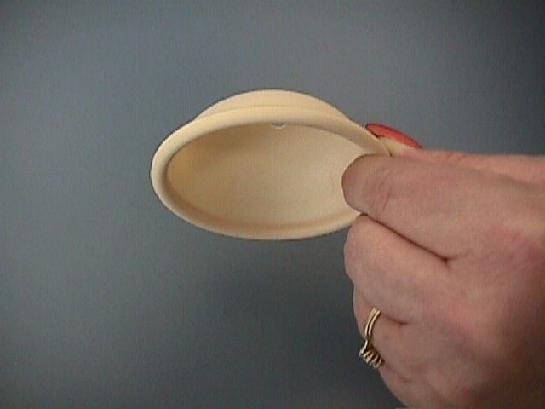
It prevents pregnancy by keeping sperm away from the cervix (the latex is impenetrable), and by holding spermicidal cream up against the cervix so that the few sperm who successfully find their way around the diaphragm are eliminated by the spermicide.

It can be inserted up to several hours prior to intercourse, and should remain in place for at least 6 hours after intercourse. If multiple episodes of intercourse occur, additional contraceptive cream may be placed in the vagina, but diaphragm should not be dislodged.

The diaphragm is very effective, with only about 5 failures per 100 women per year. Reasons for failure include non-use, improper positioning, or suboptimal use in addition to simple method failure.

Diaphragms should be individually fitted. One commonly used size is a 65-mm diaphragm (65 mm in diameter), but sizes range from 60 to 95 mm. A properly fitted diaphragm will cover the cervix completely, will not move in the vagina, and will be so comfortable that the woman will not know that she is wearing it.

Should a pelvic aching occur several hours after insertion, the diaphragm is too large and a smaller one should be substituted. If the woman complains that the diaphragm is uncomfortable or painful for her, the size should be rechecked and changed. Her partner should not be able to feel the diaphragm under ordinary circumstances.

To remove the diaphragm, insert a finger into the vagina to hook the rim of the cervix. Pull it straight out and the flexible rim will fold as it comes out.

After each use, the diaphragm should be washed with warm water and soap, rinsed well, and allowed to dry before returning it to its' case.

Women with latex allergy cannot use the diaphragm as it will cause a reaction. There are non-latex diaphragms available, but they may prove difficult to obtain.

Women who are sensitive to nonoxynol-9, the active ingredient in spermicidal creams, may or may not tolerate the diaphragm.

A diaphragm is generally a good choice for women for whom a 5% failure rate each year is acceptable. It offers reasonably reliable contraception when needed without the potential side effects of hormonal contraception and infectious complications of IUDs. It has less of an "artificial" feel than condoms.

A diaphragm is generally a poor choice for women who are relatively inexperienced sexually. It requires a moderate degree of manual dexterity, moderate familiarity with external and internal reproductive anatomy, and sexual circumstances that allow for either pre-positioning or a brief interruption in lovemaking in order to place the diaphragm correctly.<small>
</small>

DMPA Depot Medroxyprogesterone Acetate (DMPA, or DEPO-PROVERA*) was approved in late 1992 by the FDA for use as a long-acting, injectable contraceptive. Prior to 1992, many clinicians had used DMPA for this purpose without explicit FDA approval.

150 mg of DMPA are injected IM every three months, giving failure rates of slightly less than 1%.

It is believed to exert its' contraceptive effect by some or all of the following:
- Inhibiting ovulation
- Changing cervical mucous
- Changing the lining of the uterus
- Altering fallopian tube function
- Other, as yet unclassified mechanisms

The first injection is given within 5 days of the onset of menses. It is considered effective 7 days after it is given.

DMPA should be given every 3 months, but there is a 2-4 week "grace period" at the end of the three months during which DMPA can be given and contraceptive efficacy remains unchanged.

If the injection is more than 2-4 weeks late, then backup contraception should be used for the first month.

It may be given post-partum.
- For women not breast-feeding, it should be administered within the first 5 days after delivery.

For women who are exclusively breast-feeding, it should be administered during the 6th post-partum week.

The following are considered reasons to avoid giving DMPA. Some might be considered absolute contraindications, while others are more relative. In general, you should avoid both.
- Undiagnosed vaginal bleeding
- Known or suspected pregnancy
- Known or suspected breast cancer
- Active thrombophlebitis
- History of embolism or cerebrovascular disease
- Active liver disease or dysfunction
- Known hypersensitivity to DEPO-PROVERA

Measurable changes in bone mineral density occur, but this loss is not associated with an increased risk of pathologic fractures.

The greatest loss is early in the use of DMPA and slows with longer use. The clinical significance of this finding is uncertain.

Menstrual changes are the rule and not the exception among women using DMPA. Half of all women will develop amenorrhea by the end of one year's use. Spotting and intermenstrual bleeding intermenstrual bleeding are also common. Occasionally, this bleeding can be heavy.
These abnormalities are often simply tolerated and considered an acceptable side effect of this form of contraception. Alternatively, you may discontinue the injections and allow the drug to wear off. Finally, you may treat the abnormal bleeding with small doses of estrogen or oral contraceptive pills, but the impact on contraception of such treatment is unknown and patients should use backup contraception methods while BCPs or estrogen is being given.

Ovulation resumes, on average 4.5 months after the last injection. Delay to conception after the last injection is approximately 10 months.

In an uncontrolled study, 60% of women using DMPA gained weight during the first 6 months of use. The magnitude of the weight gain was 5 pounds at the end of 1 year, and 15-16 pounds at the end of three years.

The problem with this study was the absence of a satisfactory control group. Many BCP studies have demonstrated the trend of women, as a group, to gain weight over time, whether they take BCPs or not.

DMPA use probably does lead to some degree of additional weight gain, but the magnitude of this gain is uncertain.

Headaches, breast tenderness, and psychological changes have all been described, but are uncommon. They may be temporary, so simply watching to see if they disappear is warranted unless the symptoms are severe.

Among the psychological effects are diminished libido, fatigue, depression, and nervousness. There is no way of reversing the effects of DMPA other than letting it wear off, a process, which takes 4.5 months, on the average.

If pregnancy occurs despite the use of DMPA, there is no good evidence that the DMPA will be harmful to the pregnancy. Because of theoretical concerns, DMPA should not be taken if pregnancy is known or suspected.

*DEPO-PROVERA is the registered trademark of Pharmacia & Upjohn Company, Bridgewater NJ

<big><big>Emergency Contraception </big></big>Within 72 hours of unprotected intercourse, birth control pills can be taken in such a way as to reduce the likelihood of pregnancy occurring.

Two Ovral (not Lo-Ovral) are taken, followed 12 hours later by two more Ovral pills. No additional pills are taken. Should Ovral not be available, good alternatives include:
- Lo-Ovral (four pills initially, followed by four more, 12 hours later)
- Nordette (four pills initially, followed by four more, 12 hours later)
- Levlen (four pills initially, followed by four more, 12 hours later)
- Triphasil (four pills initially, followed by four more, 12 hours later)
- Trilevelen (four pills initially, followed by four more, 12 hours later)

If none of these pills are available, it is likely that any standard low-dose BCP (four pills initially, followed by four more, 12 hours later) will have similar effects. These other preparations have not been studied in as much depth, however, so it is certainly preferable to use one of the listed BCPs.

With the use of emergency contraception, the risk of a pregnancy occurring is reduced by about 75%. If 100 women have a single episode of unprotected intercourse during the middle two weeks of their menstrual cycle, normally about 8 of them will conceive. If they all use emergency contraception, only about 2 of them will conceive, a 75% reduction in risk of pregnancy.

The greatest experience with emergency contraception has been within the 72-hour window. Some studies find emergency contraception is most effective the sooner it is initiated within that 72 hours. Other studies find no difference in pregnancy rates. A few studies have looked at the use of emergency contraception for up to 120 hours after unprotected intercourse and find that it can still be effective in some cases, even after 72 hours.

The menstrual cycle is usually unaffected by the use of emergency contraception. Breast tenderness is variable. Significant nausea occurs in about half of women and vomiting affects in about one in 6 women. These symptoms generally disappear within a day or two and can be moderated by using any standard anti-emetic or anti-nausea drug starting an hour before the BCPs are taken. If started after the onset of symptoms, these medications are not likely to be effective.

The mechanisms by which this contraceptive effect occurs have not been established, but should a pregnancy occur despite the use of these BCPs, there is no evidence of harm to the fetus from having been exposed.

Contraindications to use of emergency contraception are essentially the same as those for use of the birth control pill in general. Previous stroke, undiagnosed uterine bleeding, heart attack, deep vein thrombophlebitis and cancer of the breast or uterus are all contraindications to sustained pill use. The extent to which they represent risks in the context of emergency contraception is not known, but should be weighed in evaluating a patient for emergency contraceptive use.

Female Condom Female condoms can be very effective in preventing pregnancy and providing reasonable protection against some sexually transmitted diseases. Each female condom is individually packaged and pre-lubricated. It is made out of plastic, not latex, so it is particularly useful for women and men with latex allergies. Each package contains an extra small tube of lubricant.
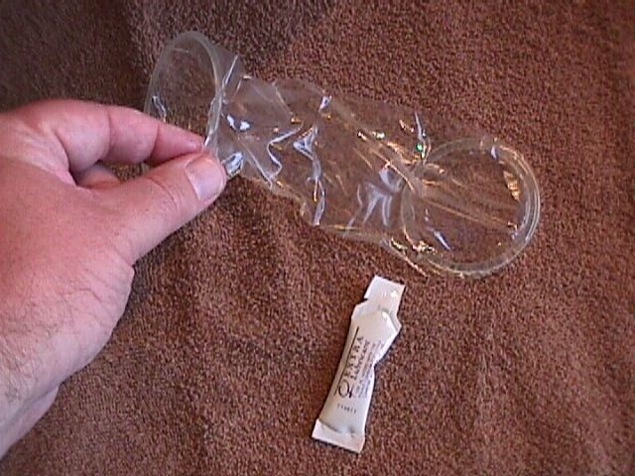
After removal of the condom from its' package, the inner ring is compressed into an oval shape. The inner ring is then inserted deeply into the vagina, so that it encircles the cervix. With proper positioning, the exterior ring will cover the vulva and remain outside the vagina.

During intercourse, the penis is inserted through the outer ring into the vagina. It is a good idea to hold the outer ring in place while the penis is initially inserted.

After intercourse, the outside ring is twisted to seal the semen inside the condom. Then the condom can be gently pulled straight out. It should be discarded in a trash container and not flushed, as it may clog the toilet.

Although pre-lubricated, women may find they need additional lubrication. Some women can feel the condom inside the vagina and others cannot. Extra lubrication can be helpful if this sensation is a distraction.

Some women find that intercourse while using the female condom produces distracting sounds. In this case, the use of additional lubricant can be helpful in silencing the noise.

Additional spermicide (cream, foam or jelly) can be used safely with the female condom, although the degree to which this provides additional contraceptive effect is unknown. If extra spermicide is to be used, it is most likely to be helpful if placed in the vagina prior to insertion of the female condom.

The effectiveness of the female condom in preventing pregnancy is roughly the same as the use of a diaphragm. When used carefully and consistently with each episode of intercourse, there will be about 5 failures per 100 women per year (95% effective). When all women who use this method are evaluated, including those whose use is not always careful and not necessarily consistent, the annual failure rate (pregnancy rate) is about 20%.

Contraceptive Vaginal Film Contraceptive vaginal film is available for use as either a primary method of contraception or to increase the effectiveness of other methods, such as condoms.

Each film is a semi-transparent square of a dissolvable material containing nonoxynol-9, a standard spermicide.
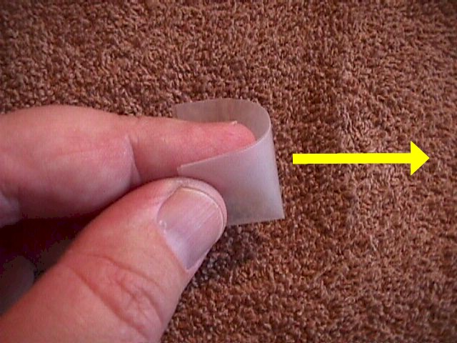

After opening the individual film wrapper, the film is removed and folded once in half. Use dry fingers; otherwise the film will begin to melt and will become unmanageable.

The film is then folded in half once again and folded over the index or middle finger. Push the folded film deep into the vagina so that it is up against the cervix.

After insertion, the film needs 15 minutes to melt to form an effective spermicidal barrier. Once in place, it is effective for up to one hour after insertion. If additional intercourse is performed, an additional film should be inserted.

The film dissolves completely and does not need to be removed. It will be discharged over time with the normal vaginal secretions and body fluids. If douching is desired, it should not be done during the first 6 hours after intercourse as some of the contraceptive protection may be lost.

Because the active ingredient is nonoxynol-9, some individuals (up to 20% of the population) will be sensitive to it and experience a burning sensation during use. Those individuals should not continue to use this method of contraception and should seek another alternative.

Effectiveness of the film is probably similar to that of the diaphragm. If used carefully and consistently, about 5 women out of 100 will become pregnant each year, despite the use of contraceptive vaginal film. For the average user, failure rates are likely higher, about 15 or 20% each year.

Contraceptive Foam Contraceptive foam is a good contraceptive choice for many women.

Foam comes in a pressurized container with a plastic applicator. After placing the aerosol container in an upright position on a solid surface, the applicator is positioned over the top of the can and gentle downward pressure exerted. This pressure will release foam into the applicator, gradually filling it. The applicator should be filled to the ribbed section (about 80% full).

The applicator is then inserted into the vagina and the plunger depressed with the index finger, pushing the foam into the vagina. It is immediately effective, and remains effective for up to one hour after insertion. If intercourse is repeated, a second applicator of foam should be used..

The foam will gradually leak out of the vagina over the next several hours. If douching is desired, it should not be done during the first 6 hours after intercourse, because some of the contraceptive effectiveness of the foam may be lost.

After each use, the applicator should be washed with warm water and a mild soap. The applicator may be disassembled for cleaning.

The active ingredient in the foam is the standard spermicide, nonoxynol-9. This is also the material, which may produce a local burning sensation in up to 20% of those using it. If the woman or her partner has this sensitivity, he or she will be sensitive to any of the nonoxynol-9 products (gel, cream, etc.).

Effectiveness is similar to that of the diaphragm. If used carefully and consistently, about 5 women out of 100 will become pregnant each year, despite the use of contraceptive foam. For the average user, failure rates are higher, about 15 or 20% each year.

Contraceptive Vaginal Gel Contraceptive vaginal gel is used either alone or in combination with other contraceptive techniques such as condoms.

Each gel applicator is individually wrapped and contains nonoxynol-9, a standard spermicide.

After opening the package, the cap is removed and used as a plunger for the applicator.

The applicator is pushed into the vagina and the plunger depressed to deposit the gel inside the vagina.

After insertion, the gel is effective immediately. Once in place, it is effective for up to one hour after insertion. If additional intercourse is performed, additional gel should be inserted.

The gel forms a spermicidal barrier within the vagina. It does not need to be removed as it will gradually discharge over the next few hours. Douching, if desired, should not occur during the first 6 hours after use, because some of the contraceptive protection may be lost.

Because the active ingredient is nonoxynol-9, some individuals (up to 20% of the population) will be sensitive to it and experience a burning sensation during use. Those individuals should not continue to use this method of contraception and should seek another alternative.

Effectiveness of the vaginal gel is similar to that of the diaphragm. If used carefully and consistently, about 5 women out of 100 will become pregnant each year, despite the use of contraceptive vaginal gel. For the average user, failure rates are likely higher, about 15 or 20% each year.

Intrauterine Device (IUD) IUDs have been known and used for thousands of years in large domestic animals, but only recently have humans used them.

Modern IUDs are easily inserted, have a very high effectiveness rate (98-99%), and are well tolerated by most of the women who use them. Their effectiveness continues for varying lengths of time, depending on the type of IUD. The "Copper T 380A," used frequently in the United States, can remain in place for 10 years before removal is recommended.

IUDs tend to make menstrual flows somewhat heavier, crampier and longer, a consideration in assessing the appropriateness of an IUD for any individual patient.

While many IUDs were known to be safe and effective, one in particular, the Dalkon Shield, seemed to have more than its' share of problems, the most important of which was infection. Pelvic infections, infrequent and usually minor with the other IUDs, tended to be more frequent and more severe among Dalkon Shield users. Many of these infections were so serious as to render the patient permanently sterile or to necessitate a hysterectomy.

There were two reasons for these infections; a design flaw and a marketing flaw. The design flaw was located in the "tail" or string used to remove the IUD. After insertion, the string is left protruding through the cervix so it is visible on pelvic exam. This confirms that the IUD is correctly placed and facilitates removal at a later date. The Dalkon Shield string was made up of many tiny plastic filaments and encased in a plastic sheath. This design inadvertently caused the string to act as a wick, constantly drawing vaginal bacteria up through the cervix and into the uterine cavity where they could cause infection. The other IUDs had monofilament strings, which did not have the same wicking capacity. The design, in retrospect, predisposed the Dalkon Shield to infections.

The marketing flaw was to promote IUD among young, single women without children. These women tended to have greater risk of exposure to sexually transmitted disease and multiple sexual partners. They tended to be more likely to seek medical attention late in the course of the illness. The consequences of permanent infertility among these young women was devastating.

While the design and marketing flaws of the Dalkon Shield are of primarily historical interest, the lessons learned at a terrible cost should not be forgotten in looking at more modern IUDs.

With the newer designs, the risk of infection has been significantly reduced. Sooner or later, about 3-5% of IUDs will be removed because of infection. Most of these infections are minor, with mild symptoms of vague pelvic discomfort, painful intercourse and possibly a low-grade fever. The uterus is tender to palpation although the adnexa usually are not. Treatment of such mild infections generally involves prompt removal of the IUD, oral broad-spectrum antibiotics and complete resolution of symptoms. Infertility following such mild infections is uncommon.

With the less common, serious infections, a high fever can be found, movement of the cervix causes excruciating discomfort and the adnexa are extremely tender. In addition to prompt removal of the IUD, IV antibiotics are recommended to treat this moderate to severe PID. In these cases, recovery is generally slow (days to weeks) and infertility is a distinct possibility.

The overall risk of perforation of the IUD through the uterine wall is about 1 in 1,000. Most of these occur during the insertion of the IUD or shortly thereafter. More common than perforation is the "disappearance" of the IUD string. While such a disappearance may suggest the possibility of perforation, a more likely explanation is that the string has coiled up inside the cervical canal or even inside the uterus.

A truly perforated IUD is usually removed from the abdominal cavity with laparoscopic or open surgery.

When confronted with a missing IUD string, most clinicians will gently probe the cervical canal to see if they can tease the string back down through the os. A cotton-tipped applicator or a Pap smear brush works well for this purpose. Once the string is brought down into the vagina (and about 3/4 will be found this way), nothing further needs to be done.

If the string is not inside the cervical canal, then further evaluation and treatment will be needed from an experienced and well-equipped gynecologic consultant. X-ray can confirm that the IUD remains somewhere within the pelvis. Ultrasound can demonstrate the presence of the IUD inside the uterine cavity. For an IUD which is clearly inside the uterine cavity but whose string has retracted into the cavity, a careful judgment must be made.

In some circumstances, the IUD is removed with an IUD hook, D&C or hysteroscopy, and a new once replaced. In other circumstances, it may be appropriate to leave the IUD where it is until the 10 years have expired before removing it.

IUDs are very effective at preventing pregnancy, but there is a small failure rate of about 1-2% each year. If pregnancy occurs, it is important to remove the IUD immediately (that day). The normal spontaneous miscarriage rate is about 18-20%. For women who conceive despite an IUD, the miscarriage rate is about 25% when the IUD is removed immediately. If the IUD is left in place, the miscarriage rate increases to about 50%, and many of those are septic mid-trimester losses which are particularly unpleasant and which are associated with subsequent infertility in some cases.

If deployed, even the relatively inexperienced health care provider can remove the IUD. 1) it is simple and easy to do, and 2) delaying removal for several days until a more experienced provider can see the patient risks retraction of the string up inside the uterus, making simple removal impossible. The IUD should first be removed and then the patient moved to a definitive care setting in anticipation of a possible miscarriage.

Should a pregnancy occur despite the presence of an IUD, there is an increased likelihood that it will be an ectopic pregnancy. Instead of the typical rate of about 1%, the ectopic pregnancy rate is about 5%. This means that in addition to prompt removal of the IUD, the patient needs a careful evaluation with ultrasound and possibly adjunctive laboratory tests to determine the presence of the pregnancy. Should an ectopic pregnancy be found, medical and/or surgical management is usually undertaken.

In many military settings, such an evaluation may not be possible and medical evacuation should be considered.

A good candidate for an IUD is:
- an older woman with children, who is in
- a stable, mutually monogamous sexual relationship, and who is
- not planning additional pregnancies.

A bad candidate for an IUD is:
- a young woman with no children, with
- multiple sexual partners, with a history of PID in the past, who would like to have children at some time in the future.

Most women considering an IUD don't fit perfectly into either category, so some judgment must be used. Contraindications to IUD use include:
- Known or suspected pregnancy
- Known distortion of the uterine cavity
- PID past or current
- Pregnancy-related infection within the last 3 months
- Known or suspected cervical cancer
- Undiagnosed vaginal bleeding
- Current cervicitis or vaginitis until effectively treated
- Wilson's disease
- Allergy to copper
- Impaired immune system
- Genital actinomycosis

An IUD can be inserted at any time, provided the physician is confident that the patient is not currently pregnant. Many physicians prefer to insert the IUD during a normal menstrual flow. This provides some assurance that the patient is not currently pregnant. Second, the cervical canal is already somewhat dilated from the menstrual flow and so the actual IUD insertion is more comfortable for the patient. Third, there is usually a small amount of bleeding following insertion of the IUD which will not be noticed if the patient is currently flowing. The IUD may be inserted at the 6-week postpartum check.

Insertion usually causes mild uterine cramping which disappears in a few minutes. Pretreatment with a NSAID can block much of that discomfort. The use of prophylactic antibiotics is an unresolved controversy.

An IUD can be removed at any time, but should be removed in the presence of pelvic infection, pregnancy, and abdominal pain of uncertain cause or if the IUD is already partially extruded. Never push a partially extruded IUD back inside the uterus as you will introduce significant bacterial contamination into either the uterus or the abdominal cavity, whichever area you penetrate.

After placing a vaginal speculum, visualize the cervix and the IUD string(s) protruding through the cervical os. Grasp the strings with any convenient instrument (hemostat, dressing forceps, ring forceps, etc.) and pull the IUD straight out with a steady, smooth, slow pull. The IUD, by virtue of its' pliability, will fold onto itself and slide out. Most patients will feel either no discomfort or minimal uterine cramping during removal. They generally comment that having the IUD removed was not as uncomfortable as having it inserted.

Norplant Norplant consists of six soft, flexible Silastic tubes, each containing levonorgestrel (LNG, the same progestational agent found in LoOvral), and implanted just below the skin of the inner, upper arm. The tubes are 34 mm long and 2.4 mm in diameter, and initially release about 85 mcg of LNG each day. In time, the daily release of LNG falls, ultimately stabilizing at about 30 mcg per day. If left in place, the tubes continue to effectively prevent pregnancy for at least 5 years.

It is believed to exert its' contraceptive effect by some or all of the following:
- Inhibiting ovulation
- Changing cervical mucous
- Changing the lining of the uterus
- Altering fallopian tube function
- Other, as yet unclassified mechanisms

When removed, fertility returns promptly.

During the first year of use, the failure rate is 0.2%, comparable to the failure rate of BCPs. During the next 5 years, the failure rate rises slowly to about 1% by the 5th year.

Contraindications include:
- Undiagnosed vaginal bleeding
- Known or suspected pregnancy
- Known or suspected breast cancer
- Active thrombophlebitis or thromboembolism
- History of idiopathic intracranial hypertension
- Benign or malignant liver tumors or other acute liver disease
- Known hypersensitivity to LNG or Silastic

About half of all women using Norplant will experience abnormal bleeding patterns, consisting of spotting, prolonged bleeding, unpredictable onset of flow and amenorrhea, primarily in the first year of use. While overall, the number of days of some bleeding in these women usually increases, the total amount of blood loss usually decreases, and anemia is not a problem. This side effect, abnormal bleeding, is generally tolerated and no treatment is necessary. For the woman who is quite distressed, or in whom the bleeding is clinically significant, control with BCPs is usually effective, but may alter the effectiveness of the method and theoretically could lead to an increased risk of thrombophlebitis or other hormone-related side effect. Removal of the implants may occasionally be necessary.

Weight gain, weight loss, nausea and depression have all been reported in association with this drug, but it is unknown whether they occur more frequently among women using the implants or not using the implants. If the symptoms are mild, toleration will usually bring relief in time. If symptoms are severe, removal of the implants may be necessary.

Infection at the implant site is an uncommon complication (0.7%), but is treated by removal of the implants, bacterial cultures and antibiotics.

The implants are inserted in the inner, upper arm (non-dominant side), 8-10 cm above the elbow crease, in a fan-like pattern, just beneath the dermis.

When in place, they are typically invisible, but may be seen in extremely thin patients.

In women with darker skin tones, a hyperpigmentation (even darker area) may develop over the implants, outlining their position, but this coloration is temporary and resolves after removal of the implants. They can be felt, but will not move or migrate away from the insertion site.

After giving a small amount of local anesthetic, a 2-mm incision in the skin is made and a trocar introduced. Through the trocar, the Silastic tubes are inserted in a fan-like fashion. The incision to closed with a steri-strip.

For removal, local anesthetic is injected to allow a 3-5 mm skin incision at the base of the "fan." 3 ml of anesthetic in injected beneath the implants. Push one implant toward the incision with your fingers and grasp it with a hemostat. Before it can be removed, you will need to open the fibrous capsule, which will have developed around the implant. Open the capsule with a scalpel or another hemostat. Then grasp the implant and pull it straight out through the incision. Continue in the same way with the other implants until all 6 are removed.

Sometimes, there will have been some migration of the implants, making removal of all of them difficult. Under these circumstances, if reasonable efforts to retrieve all of them are not successful, it may be better to stop, wait 4-6 weeks for healing and resolution of any inflammation, and then try again.

New implants may be inserted at the time of the removal of the old ones, either in the same or in the opposite direction

*Norplant is the registered trademark of the Wyeth-Ayerst Laboratories, Philadelphia, Pennsylvania

Illustrations Courtesy of Wyeth-Ayerst Laboratories, Philadelphia, Pennsylvania

Rhythm The rhythm method of contraception involves avoiding unprotected intercourse during the fertile time.

Ovulation occurs approximately 14 days prior to the onset of the menstrual flow. For women with regular, predictable menstrual periods, this means that by avoiding unprotected intercourse around the time of ovulation, pregnancy can be prevented.

Fertilization must occur within 24 hours of ovulation to be successful. Sperm can appear at the end of the fallopian tube within 10 minutes of male orgasm and can remain there for at least 48 hours, sometimes longer.

For a woman with regular, predictable periods occurring every 28 days, avoiding unprotected intercourse from approximately day #9 through day #19 (5 days on either side of the expected ovulation) will provide reasonable protection against pregnancy (70-80%). Failures occur because of:
- Earlier than expected or later than expected ovulation.
- Sperm living longer than expected in the fallopian tube.

For women with longer menstrual cycle frequencies (32 days, for example), the days to avoid unprotected intercourse should be adjusted. For a 32-day cycle, ovulation usually occurs 14 days prior to menses, on day #18. This means avoiding unprotected intercourse from day #13 through day #23.

If fewer than 5 "off days" on either side of ovulation are used, this method will be less effective. If more than 5 "off days" are used, this method becomes more acceptable. It can never be 100% effective, however, since pregnancies have been recorded following intercourse on any day of the menstrual cycle.

If an annual failure rate of 20-30% is not acceptable, or if menstrual periods are irregular, other forms of contraception may prove more satisfactory.

Vaginal Suppositories Each suppository is individually wrapped and contains nonoxynol-9, a standard spermicide.

After opening the package, the suppository is pushed deeply into the vagina so that it lies against the cervix.
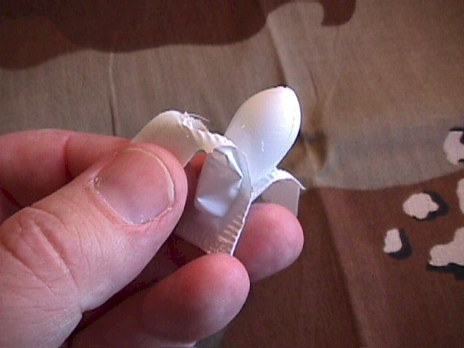

After insertion, the suppository needs 10 minutes to melt to form an effective spermicidal barrier. Once in place, it is effective for up to one hour after insertion. If additional intercourse is performed, an additional suppository should be inserted.

The suppository forms a spermicidal foam barrier within the vagina. It does not need to be removed as the foam will gradually discharge over the next few hours. Douching, if desired, should not occur during the first 6 hours after use, because some of the contraceptive protection may be lost.

Because the active ingredient is nonoxynol-9, some individuals (up to 20% of the population) will be sensitive to it and experience a burning sensation during use. Those individuals should not continue to use this method of contraception and should seek another alternative.

Effectiveness of the vaginal suppository is similar to that of the diaphragm. If used carefully and consistently, about 5 women out of 100 will become pregnant each year, despite the use of contraceptive vaginal suppository. For the average user, failure rates are likely higher, about 15 or 20% each year.

Tubal Ligation Tubal ligation is a highly effective method of permanent sterilization. It is a surgical procedure that can be performed in a number of different ways, including outpatient laparoscopic surgery, post partum surgery, or during a cesarean section.

It is approximately 99% effective (failure rate of about 1%).

It should be considered permanent and irreversible, although in some cases, following major surgery, it can be successfully reversed. It is not a good choice for anyone who may wish to have children in the future.

The advantages are permanent sterilization, with no need for hormones, mechanical or chemical methods to prevent further pregnancy.

The disadvantages relate primarily to the surgical procedure itself: infection, bleeding, injury to other organs, and anesthesia complications. These are uncommon with this type of surgery.

Vasectomy Vasectomy is a highly effective method of permanent male sterilization. This surgical procedure is usually performed as an outpatient, using local anesthetic, and lasting a few minutes. The vas deferens (tube connecting the testicle to the urethra) on each side is tied off. After a number of later ejaculations, during which the remaining downstream sperm disappear from the system, permanent sterilization is achieved.

It is approximately 99% effective (failure rate of about 1%).

It should be considered permanent and irreversible, although in some cases, it can be reversed. The greatest success rates at reversal are achieved if reversal occurs soon after the vasectomy. The longer reversal is delayed, the less effective it is likely to be. For men who may wish to have children in the future, vasectomy is not a good choice.

The advantages are permanent sterilization, with no need for hormones, mechanical or chemical methods to prevent further pregnancy.
The disadvantages relate primarily to the surgical procedure itself: infection, bleeding, injury to other organs, and anesthesia complications. These are uncommon with this type of surgery.

Withdrawal Around the world, withdrawal is the most commonly used form of contraception.

Also known as "coitus interruptus," or "pulling out," the penis is withdrawn from the vagina just before ejaculation. Orgasm is usually completed by manual stimulation.

Withdrawal has some significant advantages:
- It is reasonably effective (80-90%).
- It involves no mechanical devices, medications, or chemicals
- It is always available and requires no preparation

Withdrawal as a contraceptive method has some problems:
- Its' effectiveness is very dependent upon the male sense of timing. Some men are more skilled at this than others.
- It requires mental resolve on the part of the male at the precise moment when the power of passion and instinct is formidable.
- Because of the pre-orgasmic secretion of male prostatic fluid, some sperm may be deposited in the vagina even before ejaculation has occurred.
- During the few minutes after ejaculation, the initially thick, globular semen liquefies. In this more liquid form, it is relatively easy for some of the semen to come into contact with the vulva, particularly if there is continuing intimate contact. Pregnancies have occurred under these circumstances, even without vaginal penetration, although they are not common.
- Some men find withdrawal to be psychologically and physically less satisfying for a variety of reasons. The sensations are not identical to orgasm at full penetration, and the sense of completion is different.
- Some women find withdrawal to be psychologically and physically less satisfying for similar reasons.

