Breast Problems

Breast Development At puberty, the female breast develops, under the influence of estrogen, progesterone, growth hormone, prolactin, insulin and probably thyroid hormone, parathyroid hormone and cortisol. This complex process typically begins between ages 8 to 14 and spans about 4 years.

The breast contains mostly fat tissue, connective tissue, and glands that following pregnancy, will produce milk. The milk is collected in the ducts and transported to 15-25 openings through the nipple.

During the menstrual cycle, the breast is smallest on days 4-7, and then begins to enlarge, under the influence of estrogen and later progesterone and prolactin.

Maximum breast size occurs just prior to the onset of menses.

The breast is not round, but has a "tail" of breast tissue extending up into the axilla (or armpit).
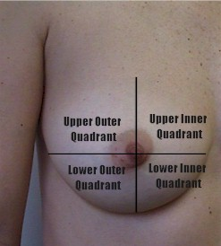

This is clinically significant because abnormalities can arise there just as they can in other areas of the breast. During breast examinations, this area should be palpated.

The breast is divided into quadrants to better describe and compare clinical findings. The upper outer quadrant is the area of greatest mass of breast tissue. It is also the area in which about half of all breast cancers will develop.

Breast Examination A breast examination consists of inspection and palpation of the breasts to identify abnormalities. Some breast examinations are focused on specific issues while others are more general. Although there are many good ways to examine the breasts, one of them will be presented here.

With the patient in a sitting position, inspect the breasts visually. While inspecting, look for:
- Visible masses (change in contour)
- Skin dimpling
- Nipple retraction
- Redness

While generally symmetrical, many breasts are somewhat asymmetrical in respect to size, shape, orientation, and position on the chest wall.

Have her raise her arms while you continue to watch. An underlying malignancy can fix the skin in place. Raising the arms will accentuate these changes.

Flex the pectoralis major muscles. A simple way to do this is have her place her hands on her hips and squeeze inward. With flexion of the underlying muscle, areas of breast tissue that are fixed in place will move with the muscle, while the rest of the breast will not.

With the patient's arm raised over her head, palpate for lumps, masses or thickenings. Breast tissue is normally somewhat nodular or "lumpy," particularly in the upper outer quadrant
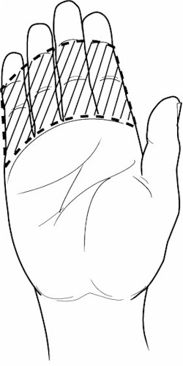
Use this portion of your hand to feel for lumps. The palm of the hand is too insensitive to detect subtle changes in breast texture. The fingertips are too sensitive and will focus on the normal granularity of the breast tissue rather than the more worrisome masses.

Move your hand in a circular motion while pressing into the breast substance. Making these small circles will help you identify mass occupying lesions.

With smaller breasts, palpation with one hand will give good results. When breasts are larger or pendulous, it may be useful to use two hands, compressing the breast tissue between them.

Check the axilla for masses or palpable lymph nodes.

The supraclavicular area can be an area of spread of breast malignancy. Check for any palpable masses or lymph nodes in this area.

Then have the patient recline. Sometimes, lumps or masses are better appreciated in the reclining or semi-reclining position. One or two hands can be effectively used. The axilla can be checked in the reclining position or semi-reclining position. The supraclavicular area can also be examined in the reclining or semi-reclining position.
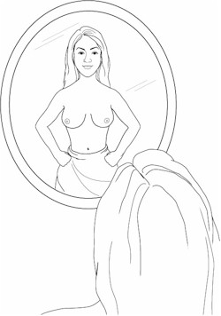
Stripping the ducts toward the nipple will cause any secretions to be expressed.

Self Breast Exam Self breast exam comprises one portion of the triad of early detection of breast abnormalities, the other two being professional breast exams and screening mammography. This is appropriate, as the woman herself first discovers most breast abnormalities.

Once a month, just after completing a menstrual flow, a woman should examine her breasts. This can be done in the shower, but at least part of the exam should be done while standing in front of a mirror.


Inspect the breasts for:
- Skin changes
- Redness
- Visible bumps
- Nipple crusting
- Symmetry

When raising her arms up, both breasts should rise evenly on the chest wall. While raising her arms, she should watch closely for any skin dimpling or nipple retraction.
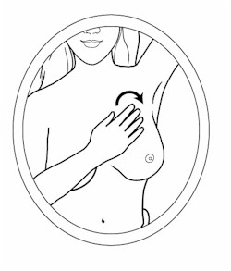

With her arm raised, she should feel for lumps with the opposite hand. Most breast tissue is somewhat nodular. She is feeling for a "marble in a bag of rice."

She should move her hand in small circles while compressing the breast tissue. Then she should move to another area and perform the same small circular examination.


Many people find it easiest to move in a clockwise fashion to avoid missing any areas of the breast.

The same circular motion should be used to exam the armpit and the "tail" of the breast that extends up into the armpit. In the armpit, she is feeling for any breast lumps or lymph nodes. Enlarged lymph nodes are about the size of a pencil eraser, but longer and thinner.
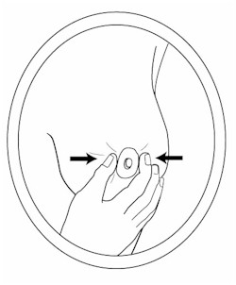

She should try to express nipple discharge by stripping the ducts towards the nipple. Normally, there will be one or two drops of clear, milky or green-tinged secretions.

Mammography Mammography is most often used as a screening technique for breast cancer.

Breast examinations detect most cancer, but will miss some, particular the very early cancers that are too small to feel. Mammograms are good at detecting some of these early cancers, but will miss others. This means that breast exams and mammograms are complementary, each detecting problems the other might miss.

Mammography looks for radio-opaque densities, microcalcifications, and disruption of the normal breast architecture (parenchymal asymmetry).

For women without strong risk factors for breast cancer, screening mammography is often done every other year between ages 40 and 50, and then annually after age 50.

Ultrasound Mammography is very good at detecting radio-opaque changes, such as calcifications or architectural distortion from a mass effect.

Ultrasound, in contrast, is very good at distinguishing cystic from solid masses. This is probably most useful following mammographic findings of a benign-appearing, non-palpable density, although it can also be used with palpable masses.

Breast Biopsy Suspicious dominant breast masses are biopsied, as are suspicious areas found on mammogram.

Commonly, this is done by fine-needle aspiration (FNA). A very thin needle is placed in the suspicious area, suction applied, and multiple, tiny core samples taken.

Alternatively, open biopsy is sometimes necessary to remove all the suspicious tissue.

Supernumerary Breasts Supernumerary breasts are relatively common. They are found along the "milk line," extending from the axilla to the groin.

Most of them are not noticed clinically until pregnancy occurs. Then, under the influence of the pregnancy hormones, the breasts enlarge in preparation for lactation. It is at this time that soft swellings along the milk line occur, representing supernumerary breasts. During lactation, the extra breasts may produce milk.

The two most common places for them are in the axilla and directly underneath the normal breast.

These are not dangerous and are generally ignored. If they prove to be a cosmetic problem, they can be removed surgically.

Supernumerary Nipples With stimulation and nipple erection, most inverted nipples will evert. Occasionally, they remain inverted despite all efforts to evert them.

Other than for cosmetics, nipple inversion is not usually a problem. For breast-feeding, most inverted nipples will evert. Even those that do not evert may still function normally enough to allow for satisfactory infant nursing.

More common than supernumerary breasts are supernumerary nipples. Like extra breasts, these are located in the milk line and are not dangerous. Unless they are large, they are usually not noticed until a pregnancy. At that time, like the normal nipples, they enlarge and darken.

Inverted Nipples Usually nipples point outward. Sometimes, they invert. When they persistently point inwards, they are called inverted nipples. This can be unilateral or bilateral.

Adolescent Breast Problems There is considerable individual variation in age at which this development occurs.

Asymmetrical breast growth during adolescence is the rule rather than the exception. Reassurance is given that the asymmetry usually evens out by the time of full maturation.

Mammary hypertrophy can be a distressing symptom. Because growth and development continues for a long time, surgical intervention, if contemplated is postponed until the breasts are fully mature.

Breast masses in adolescents are essentially 100% benign. Because of this, surgery (excisional biopsy or fine needle aspiration) is almost never warranted. Further, the surgical disruption of architecture can be disfiguring as the breast continues to mature.

Pregnancy Changes During pregnancy, a number of changes occur over time which prepare the breast for lactation:
- Early in the first trimester, the breasts and nipples become tender. The tenderness persists until the end of the 1st trimester, at which time the tenderness disappears.
- By the end of the first trimester, enlargement of the breast and nipple is noticeable.
- By the third trimester, the breast and nipple have experienced further enlargement and the Montgomery's glands around the periphery of the areola become more pronounced.
- The nipples gradually darken, becoming dark brown or black by full term.

Puerperal Mastitis During lactation, breast infections (mastitis) are common. They are usually caused by common skin bacteria (particularly staphylococcus) being introduced into the ductal system through cracked nipples and the inoculation by the newborn suckling.

Clinically, these patients present with a rapid onset of unilateral breast tenderness, redness, fever, and sometimes a thickening or mass.

Breast infections can be very aggressive with high fevers developing quickly. Immediate treatment is important to keep an otherwise simple mastitis from developing an abscess, requiring surgical drainage.
Good treatments include:
- Dicloxacillin 250 mg PO QID x 7 days
- Oxacillin 250 mg PO QID x 7 days
- Erythromycin 250 mg PO QID x 7 days
- Azithromycin 1 gm, 2 PO, then 1 PO QD

Continue to breast feed from the affected breast as drainage is important. Recurrent infections are common.

Nipple Laceration Occasionally, with vigorous nursing or newborn biting, a nipple laceration will occur. This requires careful attention to avoid a major wound infection or breast abscess.

The nipple should be kept very clean and breast feeding on that side stopped to allow the nipple to completely heal.

Instruct the patient to watch for any increasing tenderness or redness, which may be evidence of a developing infection.

Routine administration of antibiotics are generally not necessary unless the laceration is already infected or grossly contaminated.

Cyclic Breast Pain During the days leading up to the menstrual flow, the breasts normally are somewhat engorged and may be somewhat tender. Following the onset of menstrual flow, these changes spontaneously resolve. If the tenderness is more than mild or is clinically bothersome, it is called cyclic breast pain or mastodynia.

If examined during this time, these women also often have significantly enhanced nodularity of the breast tissue. the combination of cyclic breast pain and symmetrically thickened nodularity of the breast tissue is often called fibrocystic disease (misnamed because it's not really a disease) or fibrocystic breast changes.

While not dangerous, women with cyclic mastodynia find it annoying and in its most severe form, interferes with some normal activities.

Some women find that by reducing or eliminating their intake of caffeine (coffee, tea, cola drinks) and taking Vitamin E supplements (400 IU daily) has seemed to improve their symptoms. Whether such improvement is pharmacologic or placebo in nature is still under debate.

Any pharmacologic approach that suppresses ovulation will be very helpful in treating cyclic mastodynia. Among these, birth control pills are the simplest. Taking BCPs in the usual fashion generally improves the pain significantly. For those who still experience significant pain, continuous birth control pills will usually suppress the pain completely.

Also effective, by virtue of ovulation inhibition, are depot medroxyprogesterone acetate, Lupron, or Danocrine, the latter two usually justified only in severe cases due to their significant side effects.

Non-cyclic Breast Pain Among the common causes of non-cyclic breast pain are trauma, infection, and chest wall pain underlying the breast tissue (muscle strain or overuse of the pectoralis major muscle). Breast cancer rarely causes breast pain in the early stages and is not usually suspected unless the symptoms persist. Hormonal causes include functional ovarian cysts and pregnancy.

Women complaining of non-cyclic breast pain should have a careful examination and if the pain persists, referral will likely be necessary.

Nipple Discharge Normally, if the ducts are stripped toward the nipple, a drop or two of clear, milky, or greenish-tinged liquid will appear. This is not considered nipple discharge. If the nipples spontaneously leak discharge, staining the clothing, that is not normal, nor is it normal to have bloody nipple secretions.

Nipple discharge from both breasts indicates "galactorrhea." While a few post partum women will continue to leak small amounts of milk for years following delivery, galactorrhea in general indicates the need for a serum prolactin measurement and possibly an MRI of the pituitary gland to look for prolactin-secreting pituitary adenomas. Hypothyroidism can also cause this problem, although it is rare.

Athletes may experience small amounts of galactorrhea from constant rubbing of the nipples against clothing. Frequent sexual stimulation of the breasts may have similar effects. The serum prolactin measurement is best made after a few days of non-stimulation of the breast. Even after a breast exam, it is often helpful to wait 2 days before measuring the serum prolactin.

Persistent discharge from a single duct, particularly if bloody, rust-colored or multicolored, suggests the presence of an intraductal lesion, such as a papilloma. While these are often benign, they need further exploration with a general or breast surgeon.

Fat Necrosis Fat necrosis presents as a breast mass with surrounding ecchymosis (bruise). It may be tender and a history of breast trauma is identified in half the cases. Even when significant trauma is not identified, it is felt to be the general cause of this condition.

This benign condition is self-resolving, but is of clinical importance because it mimics the dominant mass found in breast cancer.

Those cases with the typical presentation can be followed to make sure they completely resolve. Those cases that are not typical or if there is any doubt, can have a fine needle aspiration to confirm the diagnosis.

Paget's Disease This crusty, flaking lesion is associated with an underlying breast malignancy, invasive or in-situ. The appearance may be suggestive of Paget's disease, but the diagnosis is generally confirmed by nipple biopsy.

The onset of the lesion is often so gradual that by the time it comes to the attention of the physician, many months or years have passed since its' onset.

Treatment depends on the character and extent of the underlying lesion.

Breast Mass If a dominant mass is found in the breast, which persists through the menstrual cycle, it is usually biopsied, either through fine needle aspiration or excisional biopsy, depending on the clinical circumstances. In operational settings, this can wait a few weeks, but should not wait much longer.

Suspicious masses (large, irregular, hard, fixed in place, with redness and dimpling of the overlying skin and nipple retraction) are usually biopsied right away.

Most masses are benign, but for those found to be malignant, earlier intervention is thought by many to lead to improved chances of successful treatment.

Breast Cyst Breast cysts present as smooth, non-tender masses. They will often disappear over the course of the menstrual cycle, but those that persist will need further evaluation.

Cyst aspiration is frequently attempted, using a small needle and syringe.
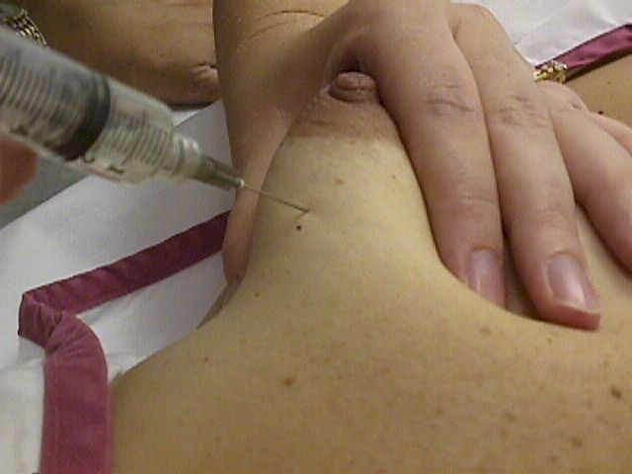

After aspiration of the cyst fluid is performed primarily to confirm the fact of the cyst and to decompress it. Many physicians discard the cyst fluid unless it is bloody as cyst fluid cytologic examination is felt to be of little value.

Following decompression of the cyst, the patient returns for periodic follow-up to look for recurrence. Recurrent cysts in the same location are often subjected to excisional biopsy or fine needle aspiration biopsy.

Fibroadenoma These common, benign, solid, round or oval breast tumors are most common among women ages 15-35. They are rubbery in consistency, mobile and non-tender. They rarely grow larger than 2-3 cm.

The diagnosis is usually suspected on physical exam and confirmed with fine needle aspiration or excisional biopsy. When found in teenagers, they are often simply watched because of the very low risk of malignancy compared to the architectural disturbance caused by excisional biopsy.

Breast Cancer Breast cancer is a relatively common cancer, representing about 30% of all cancers in women. In broad terms, treatment is successful in about 3 out of 4 patients in controlling or eliminating the cancer. In about one out of four, the cancer proves fatal.

The risk of developing breast cancer increases steadily with increasing age. It is rare among women under age 25 but affects nearly one in nine of those women reaching age 90.

A number of factors are associated with an increased of developing breast cancer, including:
- Strong family history of breast cancer
- Menopause after age 55
- No term pregnancy prior to age 35

Despite the increased risk, most (about 80%) of breast cancer occurs in women not at increased risk for developing breast cancer. For that reason, efforts at early detection are not focused just on those with somewhat increased risks, but on all women. The primary strategy involves a three-armed effort: Periodic (annual) professional breast examination, monthly self-breast examination, and mammography at appropriate intervals.

