UNITED STATES MARINE CORPS
Field Medical Training Battalion
Camp Lejeune
FMST 1406
Manage Head, Neck, and Face Injuries

TERMINAL LEARNING OBJECTIVES
- Given a casualty with either head, neck or face injuries in a combat environment and standard field medical equipment and supplies, manage head, neck and facial injuries, to prevent further injury or death. (FMST-HSS-1406)
ENABLING LEARNING OBJECTIVES
- Without the aid of references, given a description or title, identify the anatomy of the head, per the student handout. (FMST-HSS-1406a)
- Without the aid of references, given a description or title, identify the anatomy of the neck, per the student handout. (FMST-HSS-1406b)
- Without the aid of references, given a description or title, identify the anatomy of the face, per the student handout. (FMST-HSS-1406c)
- Without the aid of references, given a description, select the appropriate treatment for a head injury, per student handout. (FMST-HSS-1406d)
- Without the aid of references, given a description or list, select the appropriate treatment for a neck injury, per student handout. (FMST-HSS-1406e)
- Without the aid of references, given a description or list, select the appropriate treatment for a facial injury, per student handout. (FMST-HSS-1406f)
- Without the aid of references, given a simulated casualty with head, face, and neck injuries and standard field medical equipment and supplies, manage casualties, per the student handout. (FMST-HSS-1406g)

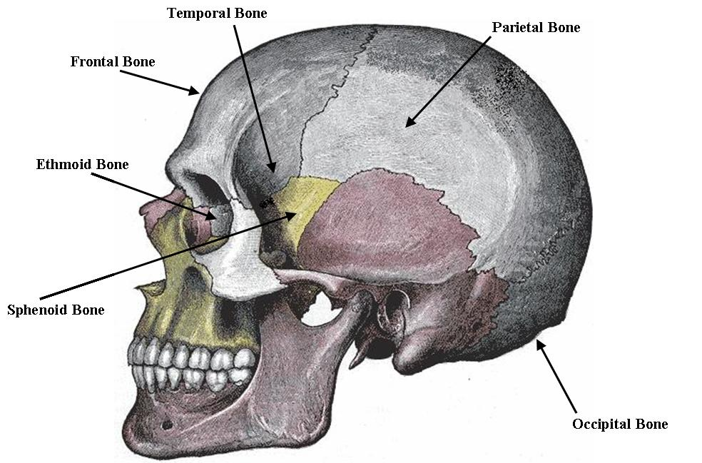
Figure 1. Anatomy of the Head

ANATOMY OF THE HEAD

Head (see figure 1)

Cranial Vault - the part of the skull that contains the brain and is divided into six sections:
- Occipital - the posterior lobe of each cerebral hemisphere that bears the visual cortex and has the form of a 3-sided pyramid
- Temporal - a large lobe of each cerebral hemisphere that is situated in front of the occipital lobe and contains a sensory area associated with the organ of hearing
- Parietal - forming the upper posterior wall of the head
- Frontal - the anterior division of each cerebral hemisphere
- Sphenoid - a winged compound bone of the base of the cranium
- Ethmoid - a light spongy cubical bone forming much of the walls of the nasal cavity and part of those of the orbits

Brain - divided into three major areas:

Cerebrum: The largest of the three subdivisions of the brain, superiorly situated and sometimes called the “gray matter”. It controls willful movement, sensory information such as hearing, speech, visual perception, emotions and personality.
The brain is protected and cushioned by aprroximately 75 ml of an internal fluid called Cerebral Spinal Fluid (CSF). The CSF also combats infection and cleanses the brain and spinal cord.

Cerebellum: Situated posterior to the brain stem and is sometimes called the “little brain” or “white matter.” It coordinates the various activities of the brain, particularly movement, coordination and balance.

Brain Stem - broken down into four parts which connect the spinal cord to the brain and cranial nerves:
Medulla - the most inferior part of the stem which contains the center that regulates respiratory rate, blood pressure, heart rate, breathing, swallowing and vomiting.
Pons - sleep center and respiratory center.
Midbrain - regulates muscle tone.
Reticular Activating System - scattered throughout the brain stem and is important in arousing and maintaining consciousness.
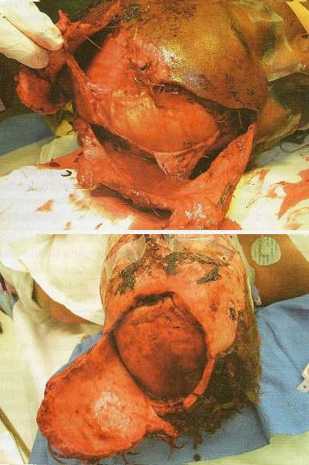
- TYPES OF HEAD INJURIES
Soft Tissue Injuries
Definition - injury to the overlying skin of the scalp, which may be in combination with injury to the skull, brain and/or face. (See figure 2)
Causes
- Penetrating trauma (rifle, impaled objects, missile wounds)
- Blunt trauma (MVA, blast)
Skull Injuries
Open Skull Injuries
Definition - injury where cerebral substance is visable through a scalp laceration. Open head injuries usually combine lacerations of the scalp, fragmentation of the skull from fractures, and lacerations of the membranes that cover the brain. The brain may be relatively untouched, or it may be extensively bruised or lacerated.
Figure 2. Injury to scalp
Causes
- Penetrating trauma
- Blunt trauma
Closed Skull Injuries
Definition - in closed head injuries there may or may not be lacerations of the scalp, but the skull is intact, and there is no opening to the brain. Injury to the brain itself may be far more extensive in a closed head injury because more of the injuring force is transmitted deeper into the brain due to pressure build-up (see figure 3).

Causes
Coup-Contrecoup - also known as a deceleration injury. It occurs when the brain strikes the frontal lobe of the skull, then is thrown back against the occipital lobe of the skull (or in the reverse order), causing the brain to bounce off both sides of the cranial vault, resulting in soft tissue damage.
Blunt Trauma - rising intracranial pressure (ICP) produces complications because the brain is enclosed and pressure cannot be relieved.

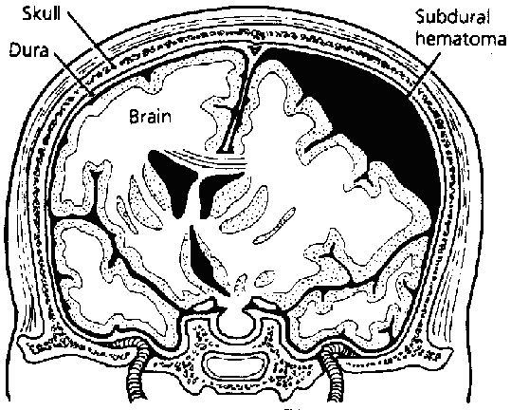
Figure 3. Closed Head Injury
Brain Injuries
Definition - results from contusion, hemorrhage and/or edema. Damage to the brain and associated intracranial hemorrhage may occur with or without scalp lacertions
or skull fractures. If the cranial vault is intact, the resultant swelling or bleeding produces more brain injury by increasing the intracranial pressure.
Causes
- Blunt trauma
- Penetrating trauma
- Coup-Contrecoup injuries

3. Signs and Symptoms of Head Injuries
Soft tissue injuries
- Profuse bleeding no matter how minor the injury
- Lacerations
- Avulsions
- Pain
- Anxiety
- Edema
- Ecchymosis
- Signs / symptoms of hypovolemic shock
Open Skull injuries
- Profuse bleeding no matter how minor the injury
- Crepitus
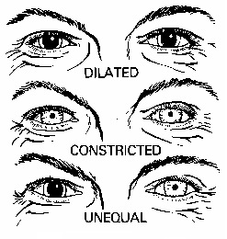
- Edema
- Depressions
- Deformities
- Visualize skull or bony fragments
Closed Skull Injuries
- Crepitus around injury site
- Headache
- Neurological symptoms:
- Altered LOC
- Restlessness
- Unequal pupils (see figure 4)
Figure 4. Pupils
- Bruising, such as:
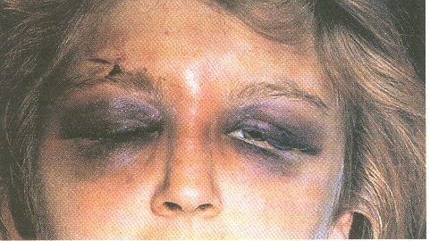
Raccoon Eyes - discoloration of the soft tissue under the eyes indicates basilar skull fracture (see figure 5).

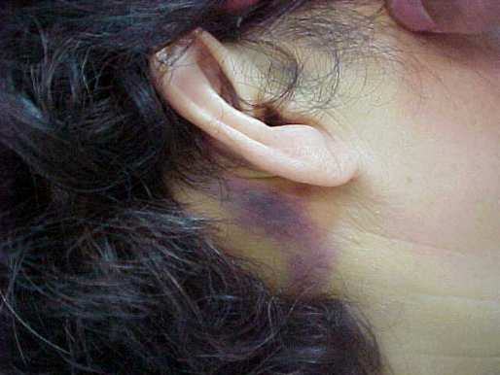

Figure 5. Raccoon Eyes

Battle’s sign - discoloration of the soft tissue behind the ear indicates temporal bone fracture. This is a late sign and may not be readily seen (see figure 6).
Figure 6. Battle’s Sign

- Drainage - drainage of cerebral spinal fluid from the ears, nose, or eyes. Blood or fluid (CSF) in the ears or nose may indicate a skull fracture.
- Bradycardia
- Increased systolic blood pressure
- Nausea/vomiting
- Decreased Respirations/Cheyne Stokes breathing pattern
- Deformity of the skull (see figure 7).
Brain Injuries - in addition to the above listed signs and symptoms for closed skull injuries, the below listed signs and symptoms may indicated a brain injury as well:
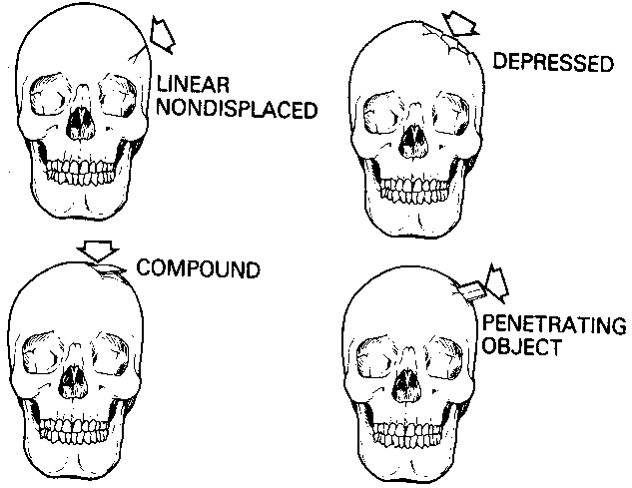
- Unusual behavior patterns. You must be careful not to misinterpret these symptoms for a psychiatric casualty. (This is the number one indicator of an injury.)
- Altered level of consciousness
- Paralysis
- Convulsions/seizures
- Hyperthermia
Determining Responsiveness (AVPU) - AVPU is an acronym used by health care providers to standardize the way of describing a patient’s mental status. The level of responsiveness aids in the determination of the casualty’s baseline. The responsiveness of the casualty can begin to be assessed from a distance as you approach a casualty by saying, “Hey, if you can hear me, crawl towards my voice!”
Figure 7. Skull Injuries
A (Alert) - is the casualty oriented to person, place, and day? If so, obtain chief complaint.
V (Verbal stimuli) - casualty’s response to verbal stimulus (appropriate or inappropriate?).
P (Painful stimuli) - casualty’s response to painful stimulus (localizes or withdraws to pain).
U (Unresponsive) - casualty is totally unresponsive.

4. TREATMENT OF HEAD INJURIES
- Provide and maintain patent airway
- Apply c-spine precautions
- Hemorrhage control. Cover open wounds securely enough to aid in the clotting process without pressing skull fragments or impaled objects inward by using donut o-ring.
- Fluid resuscitation PRN (as needed) (Do not want to raise intracranial pressure)
- Do not remove foreign bodies or impaled objects
- Check for drainage of CSF from the wound, nose, or ears. Do not pack or suction nose and/or ears if CSF leakage is suspected. Do not let patient clear their nose by blowing. If the casualty has draining from their nose, check to see if it is CSF by:
- Use the Halo, or Target Test to check for CSF. Dip a 4 x 4 in the drainage then
lay it flat and wait a few minutes. If there is CSF in the blood, the blood will
collect in the center, while the CSF remains to the outside creating a halo around
the blood.
- Give nothing by mouth (NPO)
NO PAIN MEDICATIONS!
NO PAIN MEDICATIONS!
NO PAIN MEDICATIONS!

- CASEVAC in the high Fowlers position

NOTE: There is a high mortality rate associated with head trauma. All head trauma patients are assumed to have a cervical spine injury until proven otherwise.

5. ANATOMY OF THE NECK
Structures
Esophagus - passage from the mouth to the stomach
Trachea (windpipe) - air passage from the larynx to the lungs made of connective tissue and reinforced with 15-20 C-shaped cartilaginous rings
Thyroid gland - stimulates the metabolism of all cells
Larynx (voice box) - the first part of the trachea which contains the vocal cords
Pharynx - area that extends from the soft palate to the esophagus/trachea
Epiglottis - leaf shaped structure that acts like a gate, directing air to the trachea and solids and liquids into the esophagus
Vasculature
Arteries - left/right common carotid (carry blood to brain)
Veins - left/right internal and external jugular (carry blood away from brain to heart)
Cervical Spine
Vertebrae - seven cervical vertabrae
Spinal Cord - protected by the cervical vertebrae

6. TYPES OF NECK INJURIES
Trauma of any kind to the neck is signifigant because of the risk of associated injuries to the respiratory tract, the alimentary tract (especially the esophagus), the major vascular structures, major nerves, and the cervical spine.
Structures
Definition - injury to associated anatomy of the neck most commonly the trachea and esophagus.
Causes
- Blunt trauma
- Penetrating trauma
Vasculature
Definition - injury to the carotid arteries and/or the jugular veins. These are the most commonly injured structures of the neck.
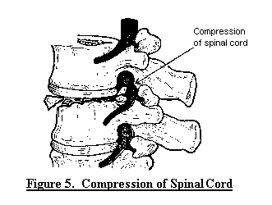
Causes
- Blunt trauma
- Penetrating trauma
Cervical Spine
Definition - fractures of the cervical vertebrae which are very susceptible to injury because of the relation and position of the skull. These fractures may result in irreversible spinal cord injury.
Causes
Figure 8. Compression Injury
- Compression injury (see figure 8).
The only definitive diagnosis for C-spine injury is x-ray. Patient should remain in C-collar until x-rays are read!

- Flexion, hyperextension and hyperrotation
- Lateral bending

7. SIGNS AND SYMPTOMS OF NECK INJURIES
Structure
- Subcutaneous emphysema
- Hematemesis
- Hemoptysis
- Dysphagia (difficulty swallowing)
- Dyspnea
- Hoarseness
- Deformity
Vasculature
- Hemorrhage
- Hemoptysis
FYI!
Cricothyroidotomy may be necessary if neck trauma causes blood to be present on the vocal cords, thus causing laryngo-spasms.
- Hematemesis
Cervical Spine
- Deformity
- Head fixed in an abnormal position
- Muscle spasms
- Parasthesia in the arms
- Pain
- Paralysis
- Neural deficits
8. TREATMENT FOR NECK INJURIES
- Consider C-spine
- Control hemorrhage with occlusive dressing. Apply pressure only to the affected vessels
- Consider cricothyroidotomy if airway is compromised
- Administer fluids (see Combat Fluid Resucitation lesson)
- NO PAIN MEDICATIONS! NO PAIN MEDICATIONS! NO PAIN MEDICATIONS!
- CASEVAC

- ANATOMY OF THE FACE (see figure 9)
The facial bones form the stucture of the face in the anterior skull but do not contribute to the cranial vault.
The major facial bones are:
- Nasal
- Zygomatic - a bone of the face below the eye that in mammals forms part of the zygomatic arch and part of the orbit
- Right/ left Maxilla - either of the two bones that lie on each side of the
upper jaw
- Mandible (jawbone) - the lower jaw.
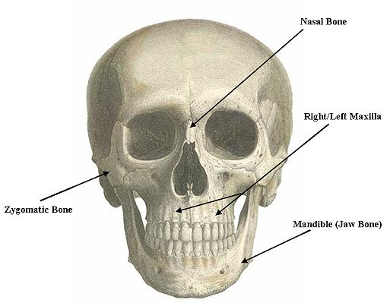
Figure 9. Major Facial Bones

- TYPES OF FACIAL INJURIES
Generally serious because of the danger of hemorrhage due to the vast blood supply of the area and obstruction of the respiratory passages.
Soft Tissue Injuries
Definition - damage to the soft tissues of the face without bone injuries
Causes
- Blunt trauma
- Penetrating trauma
Bone Injuries (Maxillofacial and Mandibular)
Definition - fracture of the major bones of the face (maxillofacial and mandibular). These fractures require great force and may be open or closed.
Causes
- Blunt trauma
- Penetrating trauma
Eye Injuries
Definition - injuries to the eyes that may be associated with other forms of head injury.
Causes
- Blunt trauma
- Penetrating trauma
- Burns
- Foreign objects-debris
Fractured Nose - prior to control of bleeding, you must determine that there is no cerebral spinal fluid escaping. If fluid is escaping, treat as a skull fracture.

11. SIGNS AND SYMPTOMS OF FACIAL INJURIES
Soft Tissue Injuries
- Massive hemmorhage even with minor wounds
- Edema
- Laceration
- Ecchymosis
- Avulsion
Bone Injuries
- Lacerated gums may indicate an underlying fracture
- Casualty cannot open mouth without pain
- Misaligned teeth
- Difficulty swallowing
- Pain at fracture site
- Edema
- Facial asymmetry
- Epistaxis (Nose bleed)
- Ecchymosis
- Lacerations
- Visual disturbances
- Limited ocular movements
- Crepitus
Eye Injuries
- Loss of vision
- Pain
- Anxiety
- Hemorrhage
- Subconjunctival hemmorrhage
- Orbital bony deformity
- Intraorbital deformity
Nose Injuries
- Blood or CSF from nose
- Bruising

12. TREATMENT OF FACIAL INJURIES
Soft Tissue injuries
- Consider C-spine
- Assess and secure airway
- Hemorrhage control
- Fluid resuscitation protocol for associated shock

Bone Injuries
- Maintain open airway. Consider use of Nasopharengeal Airway (NPA) (see figure 10)
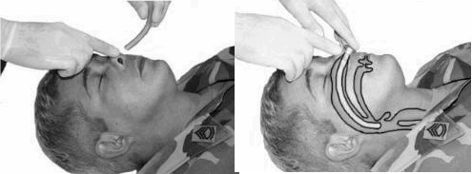
- Control hemorrhage
- NO PAIN MEDICATIONS! NO PAIN MEDICATIONS!
- Cold pack
- Modified Barton bandage for mandibular fracture (see fig 11)
- CASEVAC
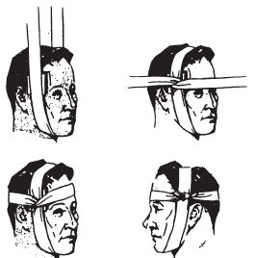
Figure 11. Modified Barton Bandage

Figure 10. NPA Insertion

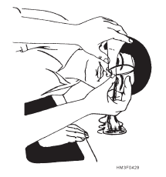

Eye Injuries
- In combat, only patch the affected eye. Member can function effectively with one eye. Member becomes a litter patient if both eyes are covered.
- If the injury to the eye is clearly a minor one, the best advice is to REFRAIN FROM INTERFERENCE. A minor eye injury improperly cared for can easily become a major eye injury.
Figure 12. Irrigating The Eye
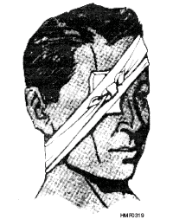
Treatment for Chemical Burns of the Eye
- Hold the face under running water with eyes open (see figure 12)
- Flush eyes 5-10 minutes for acid burns
- Flush eyes 20 minutes for alkali
- CASEVAC
Treatment for Thermal Burns of the Eye
- Cover eye with loose moist dressing
Treatment for Light Injuries
- Cover eye with loose dressing (see figure 13).
Treatment for Impaled Object
Figure 13. Simple Cravat Bandage For The Eye
- Make thick dressing and cut hole in center the size of eye opening
- Pass dressing over impaled object (see figure 14)
- Position crushed cup over dressing and bandage in place
- Elevate head to decrease intraocular pressure
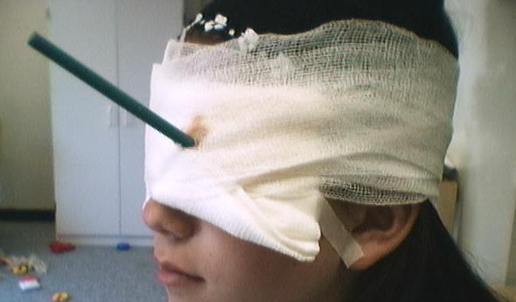
Treatment for Lacerations Involving the Eye
- If only eyelid is lacerated, direct pressure or a pressure dressing will stop bleeding.
- If the eyeball itself is lacerated, do not use pressure, but cover with a loose dressing.
Treatment for Protruding Globe
- DO NOT attempt to place eye back in socket
- Apply bulky dressing around eye, moist gauze over the globe and cover with a cup secured in place
Figure 14. Dressing Over Impaled Object
Treatment of Nose Injuries
- Hemorrhage Control
- Pinching nostrils. (Do not tilt patient head back due to postnasal drainage)
- Apply ice to bridge of nose
- Splint by padding
- Monitor and CASEVAC

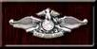 CASUALTY ASSESSMENT AND THE HEAD, NECK, AND FACE
Care Under Fire Phase: In the absense of life-threatening hemorrhage from the Head, Neck, or Face, the material in this section is unlikely to be addressed in Care Under Fire.

Tactical Field Care Phase: During Tactical Field Care, you will be required to inspect the head, neck, and face for any signs of injury. This includes looking not only for bone deformity and soft tissue injuries, signs of closed head trauma, and also consider the possibility of Traumatic Brain Injury (TBI). You must visually inspect the eyes, ears, nose, and throat. Assess the airway and intervene if necessary. Complete a head to toe assessment using DCAP-BTLS noting and treating additional injuries. Determine if vascular access is required (see Combat Fluid Resuscitation lesson) and give fluids if necessary. If a head injury is suspected, it is NOT recommended to give casualty fluids by mouth. Consider pain medications and give antibiotics if warranted. Reassess all care provided. Document care given, prevent hypothermia, and CASEVAC.

REFERENCE
Pre-Hospital Trauma Life Support, Military Edition, 6th Ed, Chapter 8

REV: July 2008
Head, Neck, and Face Review

1. Identify the function of the Cerebellum.

2. List the six key points for treatment of a neck wound.

3. List the appropriate treatment for a single eye injury in a combat situation.

4. Identify the appropriate treatment for chemical burns to the eye.

